

# Table of Contents

## Introduction……………………………………………………….................. 1

Project Context…………………………………………….....……… 2

Purpose and Description………………………………….....……... 3

Objectives……………………………………………………............ 3

Scope and Limitations…………………………………………....….4

## Review of Related Literature…………………………………………....…..5

## Technical Background………………………………………………….......16

## Design and Methodology……………………………………………...…...17

## Results and Discussion.........................................................................20

## Conclusion and Recommendation........................................................20

## Appendices…………………………………………………………….........21

Figure 1. Entity Relationship Diagram ………………………......21

Figure 2. Data Dictionary……………………………………..........22

Figure 3. Context Diagram……………………………………........23

Figure 3.1 Diagram 0……………………………………...........24

Figure 3.2 Diagram 1……………………………………...........25

Figure 3.3 Diagram 2……………………………………...........26

Figure 3.4 Diagram 3……………………………………...........27

Figure 4. Event Table…………………………………………….....28

Figure 5. Use Case Diagram………………………………….........29

Figure 6. Class Diagram………………………………………….....30

Figure 7. Object Diagram……………………………………….......31

Figure 8. State Diagram………………………………………….....32

Figure 9. Timing Diagram…………………………………………...33

Figure 10. Sequence Diagram…………………………………......34

Figure 11. Communication Diagram……………………………....35

Figure 12. Activity Diagram………………………………………....36

Figure 13. Package Diagram…………………………………….....37

Figure 14. Composite Diagram………………………………......38

Figure 15. Use Case Fully Developed…………………………..39

Figure 16. Gantt chart ………………….…………………………52

1. Statement of Work ….……………………………………………………..55
2. Project Vision and Scope ………………………………………………..57
3. Software Requirement System ……………………………………….…66
4. Quality Plan ……………………………………………………………….. 85
5. Change Management Plan ……………………………………………….91
6. Glossary …………………………………………………………………….97
7. Bibliography…………………………………………………………….......98

Project Status Report # 1 ………..………………………………………………..100

Project Status Report # 2 ………………………..………………………………..109

Project Status Report # 3 ..………………………………………………………..117

Project Status Report # 4 …………..……………………………………………..127

Project Status Report # 5 …………..……………………………………………..136

Project Status Report # 6 ……..…………………………………………………..145

Project Status Report # 7 ………………………………..………………………..154

Project Status Report # 8 ..………………………………………………………..163

Project Status Report # 9 ………..………………………………………………..172

# Abstract

In handling bulks of weather stations and their data, effectively organizing and handling data are significantly important to reduce data redundancy and data loss. To achieve efficient organization and handling of data, implementation of an Asset Management System is important to be able to keep information about the weather stations such as ID number, weather station name, location, etc. Also, a Preventive Maintenance System is strictly recommended to be implemented to, as the name implies, prevent the weather station from malfunctioning or having errors occur. This study will explain the benefits of implementing an asset management system, as well as a preventive maintenance system in the Operations and Maintenance Department of Weather.ph to efficiently and effectively handle the data and information about the weather stations of the company around the regions of the Philippines.

# Introduction

This study focuses on the creating a software solution that would improve upon the old existing system for the company called Weather.ph. What is Weather.ph? Weather.ph is a company under Aboitiz Equity, and its primary goal is to make all the people in the nation aware about the weather in the different regions of the Philippines. For example, there is a possibility of rain in Cavite while it is partially cloudy in Pasay. They want the people to be aware of the weather climate here in the Philippines. The weather station gathers the humidity reading, temperature reading, and pressure reading using different sensors that are connected to the weather station module. After gathering the data, it is transferred to a data converter through a text message. After the text message containing all the information about the readings is converted, it is then saved to the database. They gather information from weather stations that are designated at different regions in the world. The weather station sends text messages to a data converter which converts the text message to usable data for the company. Also, they handle the installation and operation of the weather machines.

## **Project Context**

In the Operations and Maintenance Department of the company called Weather.ph, they handle the data of weather stations and do maintenance on the machines. There are hundreds of weather stations which are located all over of the Philippines. From the farthest point in the north which is in Itbayat, Batanes to the farthest point in the south which is in Sulu holds weather stations that deliver important data. But there is a specific problem which arises inside the department and that is their arrangement and management of data. They’re still using Excel as a means of arranging the information of the weather station. The problem is that it could result to data being overwritten since the excel file containing the weather station data is being sent through email. This generates many copies of the same file and if changes are to be made, the updated excel file should be sent to others to keep track of the updated file. Their data and documents about weather stations are just backed up in the manager’s computer, therefore creating a security issue which could result to sensitive data to leak out.

The Operations and Maintenance Department needs a new system in where their data and documents may be arranged and managed in a way that there is order and no conflict in productivity. Another feature of the system could improve work flow of the department therefore increasing the productivity and providing room for improvement.

## **Purpose and Description**

The study on how to arrange and manage data will result in a method which will solve the problem that the Weather.ph is now facing. This method, which is an Asset Management system with a barcode implementation for the unique identification of each weather station placed all over the Philippines, when applied to a system would significantly improve the ease of arrangement and management of data within the company. The system will not only bring productivity to the department, but also increase the reliability against the loss or errors that could occur from the data and documents that they handle.

## **Objectives**

The researchers of the study have decided that the following are the main objectives of the study:

**General Objectives:**

- To improve the way of handling the maintenance to a better and faster way.

- To come up with a proposal of usable methods that can lead into create a software that will solve the problem of Weather.com.ph completely.

- To create a software solution which solves the inefficiency in the Operations and Maintenance department.

**Specific Objectives:**

* To conduct survey and research through observation and interviews.
* To come up with the conclusion based on the data gathered.

## **Scope and Limitations**

The sole department that will be using this system are the Operations & the Maintenance department. The system would require a database integration to the company’s database or a provided database from the company. Asset Management with Barcode Tagging System is accessible outside but only to the registered users within the company. The study will not cover other departments such as Financial department, Human Resources, etc. This study is also limited to the improvement of the old system by proposing a new software solution, which provides convenience and increase in productivity in the Operations and Maintenance department of the company; it will not focus on other problems in the company. The technology used in this study is limited to Weather station and the proposed software solution as well as the components of the software solution. The actors involved are the Technicians, Technician Head, Data Quality Team, Weather Station and Site Manager.

# Review of Related Literature and Related Studies

## **“Asset Management” by Steve D. Singleton; 2006**

According to the research of Steve Singleton, which entitles the “Asset Management” states that the managers in the field of this invention have a hundred or hundreds of assets or asset control devices to be managed. This given, unsecured methods have evolved around organization of the assets such that they can be readily located for use. Assets by definition have intrinsic value and in some cases require security of some kind. Some assets are themselves secured but their security can be compromised through access to a control device such as a key, remote, badge, etc. in which case the control devices themselves require security.

One example of assets requiring security is the vehicle inventory of a car or truck dealership or fleet operator. In this example, the keys and remotes for each vehicle are the control devices to be secured such that (a) only authorized users have access to them (to prevent theft and vehicle damage liabilities) and (b) each authorized user is made accountable for the vehicle keys he/she removes from the secure environment.

Another example of assets requiring security is the door keys of apartment, condominium, office, school, medical, and other buildings or groups of buildings. In this example, the building or complex maintains no master keys but keeps the management key copies in a secured environment which controls access to authorized users and records the accountability of each authorized user of each key to reduce liabilities for personal harm, theft, damage, etc. (Singleton, 2006)

In a key management system wherein a plurality of key tags are disposed to be received in a panel having a plurality of open receptacles in a security container and wherein each key tag, when received in a receptacle, has a first portion that extends below the panel and a second portion that extends above said panel, the improvement wherein said key tags are light pipes and wherein said security container houses a plurality of light sources below the top panel and where each light source is aligned with one of said receptacles, each light source being positioned to emit light into the first portion of a key tag located above the light source in the receptacle associated with the light source to illuminate the second portion of the key tag and identify it visually to a user. (Singleton, 2016)

**“Asset management system” by Andrew Canfield; 2007**

A system for managing assets includes at least one asset located within a geographic area and a server configured to store data associated with the assets. The analysis and management of data from a geographic perspective has become of great importance. Geographic information systems (GIS) have experienced increased usage by businesses and governments alike because of the ability to manipulate, analyze and present information that relates to geographic areas. The conventional GIS includes a desktop computer and/or a server based software system. The desktop computer or server stores maps, data and other related information that may be assessed by a user through the use of GIS software. The software is capable of analyzing the stored data and providing this data to the user.

The present invention provides a system for managing assets. Accordingly, an asset management system is provided that includes at least one asset located within a geographic area and a server configured to store data associated with the assets. The server may be adapted to store data associated with the asset location and be updated with current asset data by at least one administrator. The server is further adapted to generate and integrate asset symbols within an electronic spatial illustration of the geographic area wherein the location of the asset symbol on the spatial illustration corresponds to the location of the asset within the geographic area. The system further includes a portable device that communicates with the server and is adapted to display the data generated by and stored on the server. The portable device is also adapted to receive inputs from a user, display data in response to the user inputs, and display the spatial illustration having the integrated asset symbols and asset locations.

# “Goal-directed financial asset management system” by Robert R. Champion, Basil R. Twist, Jr.; 1992

Based on the researcher’s perspective, this study aims for a system determines a net position change which is translated into aggregate purchase/sale orders of various market index futures contracts or other capital instruments. The system automatically adjusts the risk exposure in any asset category to prevent its reaching an excessive level. As a result, an account can never lose more than the amount deposited. The data processing system provides efficient operation and low transaction fees to the participating investors.

What is aimed in this research, is to focus on the following claims:

1. A data processing system for administering a program to provide a future return commensurate with a selected degree of correspondence to a capital market, said system comprising: means for receiving and storing data on accounts from participating investors, including for each account a selected proportionality factor, MM, indicative of the degree of correspondence between a valuation of said account and valuation of said capital market; means for receiving adjustment requests from said participating investors for said accounts; means responsive to said adjustment requests for determining an asset transaction in said capital market wherein said asset transaction is proportional to a net aggregate value of all said adjustment requests for said asset; and means for adjusting said participating investor accounts responsive to said asset transaction and said adjustment requests.

2. The system of claim 1, wherein said capital market valuation is characterized by an index value of selected assets on said capital market.

3. The system of claim 2, wherein said means responsive to said adjustment requests includes means for determining a net purchase or sale of assets selected from the group consisting of futures contracts, options, common stocks, bonds, currencies and commodities.

4. The system of claim 3, wherein said data processing system is a stored program controlled digital computer that iteratively adjusts each investor account, pursuant to said asset transactions.

5. The system of claim 4, wherein said means for receiving adjustment requests includes means for accepting deposits or withdrawals for each investor account.

6. The system of claim 5, wherein said investor account data includes current and past valuations of said account.

7. A data processing method for administering a program to provide an investment account a rate of return commensurate with an established capital market, said method comprising the steps of:

a. Receiving and storing account parameters for said investment account, including an account asset allocation and a selected proportionality factor relating the rate of return between said investment account to said established capital market;

b. Receiving on a periodic basis a market index value (IDX), wherein said market index value represents a valuation of assets for said established capital market;

c. Receiving adjustments to said account parameters and determining a position change for said investment accounts based thereon;

d. Determining a total net position change for all participating investors at said market index value (IDX).

e. Adjusting said account parameters responsive to said position change for said investment account.

8. The method of claim 7, wherein said total net position change for all investor accounts is translated into purchase or sale-orders of assets selected from the group consisting of futures contracts, options, common stocks, bonds, currencies and commodities.

9. The method of claim 8, wherein said receiving and storing step (a) includes maintaining said MM through position changes in said account.

10. The method of claim 9, wherein said receiving and storing step (a) further comprises deposits or withdrawals (CF).

11. In combination in a data processing system for supervising an investment group of plural investment accounts, each account having investment parameters including an account balance and a proportionality factor, said data processing system comprising: market data entry means for receiving a current market index representative of a periodic valuation of a selected market; account data entry means for receiving account deposits, withdrawals and changes to said proportionality factor; means for determining an investment group investment position in the selected market in response to an aggregate adjustment to said accounts; data processing means responsive on a periodic basis to said current market index deposits, withdrawals or changes in said proportionality factor for adjusting each account so that an account valuation corresponds to the selected market index; storage means for recording net changes in account balances and said investment group investment position; and output means for interactive communication to said market and system participants.

12. In combination in the system of claim 11, wherein said proportionality factor is a factor applied to each said investment account indicative of the arithmetic relationship between an account valuation and a valuation of the selected market.

13. In combination in the system of claim 11, wherein said market index corresponds to an asset price as transacted on said selected market.

14. In combination in the system of claim 13, wherein said asset price corresponds to futures contracts on said selected market.

15. In combination in a data processing system for managing plural accounts to provide for each account a rate of return commensurate to an established form of capital, comprising; a data entry means for receiving and storing information on each said account including an account balance and a proportionality factor relating the rate of return between the account balance and the established form of capital, a customer request entry means for entering changes to the account information including deposits, withdrawals and changes to said proportionality factor for said account, a data processing means for determining an investment position contingent on an aggregation of said account information, a market communication means to effect a transaction pursuant to said investment position, and an automatic adjustment means to adjust said accounts corresponding to said transaction and said proportionality factor pursuant to preset limits regarding an exposure level for said account in said form of capital.

16. The system of claim 15 wherein said proportionality factor is a market multiple, MM(I), providing a long or short market relationship between the valuation of said form of capital on a market and the valuation of said account. contracts, options, common stocks, bonds, currencies and commodities.

17. The system of claim 16 wherein said automatic adjustment means compares an effective MM(I) for said account to a preset limit and effects a transaction that adjusts said account so that said effective MM(I) for the account is below said present limit for said account.

18. The system of claim 15 wherein said transaction is effected in assets selected from the group consisting of futures contracts, options, common stocks, bonds currencies and commodities.

**“Asset management system” by Jay Dawson ; 2007**

Based on the research, the system may include one or more data collection devices configured to monitor one or more operating conditions of a machine in real time.

In one aspect, the present disclosure is directed to an asset management system. The system may include one or more data collection devices configured to monitor one or more operating conditions of a machine in real time. The system may also include a processor configured to receive data from the one or more data collection devices and compare the received data to a set of usage terms of a warranty agreement relating to the machine. The system may be configured to communicate, in real time, to at least one of an owner and an operator, information regarding the warrant ability of the machine or its components under the warranty agreement. The communication of information may be based on the comparison of the received data to the set of usage terms of the warranty agreement.

Data collection devices may be configured to monitor operating parameters of machine 12 in real-time. For purposes of this disclosure, the term “real-time” shall refer to the immediate or substantially immediate availability of data to an information system as a transaction or event occurs. That is, data may be retrieved and available for analysis as quickly as it can be transmitted from machine 12 to processor 40. Such transmissions may be virtually instantaneous or may take a few seconds or minutes to complete.

## **“Asset Management” by FHWA 2015**

Asset management is basically organizing the assets of a company to improve efficiency and productivity as well as maintenance of the assets. According to jinisyssoftware, asset management systems make tracking assets easier and contain details which make assets more organized since this information about the assets are located inside a database which is seen in the web application of the asset management system if ever present. Benefits of implementing an asset management include improved asset tracking, improved productivity, and efficient in time handling. (Jinisys Software Inc. , n.d.)

According to the Federal Highway Administration, the proper definition of asset management, defined by Organization of Economic Cooperation and Development (OECD), is as follows:

*“[Asset Management is] a systematic process of maintaining, upgrading and operating assets, combining engineering principles with sound business practice and economic rationale, and providing tools to facilitate a more organized and flexible approach to making the decisions necessary to achieve the public's expectations. (OECD 2000)”*

FHWA explains that there are different decision levels of asset management which may interconnect and overlap because communication between the levels is important for the management process. The first and most broad is the strategic decision making level wherein its concern is with broad and generic resource allocation and utilization decisions. The next level is the network decision making level. This level is similar to the strategic level but is narrower since overall budget allocation is a focus area here and is broken down into the other lower levels such as program level and project selection level. After that level is the program decision making level which pertains to the policy decisions and focuses on the optimization of funds in the system. The next level is the project selection level which has to do with the funding for specific projects. This level needs more specific and detailed information compared to the program and network level. The last level is the project level which is the most specific of all levels due to the fact that it has to do with the design of the project which is part of the overall work plan. It is also known as the ‘field level’ or ‘operational level’. This level also shows the actual work which is needed to be done. (FHWA, 2015)

## **Barcode Tagging System: “Barcode Systems: Extend the Enterprise”**

According to Zebra Technologies, several forms of manual data collection and data entry has been replaced by the barcoding system. This is because the speed, as well as the accuracy, at which data is retrieved by barcoding is extremely quick and accurate. Zebra Technologies state that these barcoding systems are accurate 99% of the time. This is important since data entry errors could cause negative effects on a business such as a wrong input of data within a manufacturing company could cause a decrease in production due to wrong values. (Zebra Technologies, 2013) Barcode technology could greatly impact the back-end of a business for numerous reasons. One of which is an improvement of the accuracy of data. This alone could possibly be the main intention for implementing a barcode system. The reason for its accuracy is since the information is kept within the individual barcodes itself in which almost no human error could occur. According to BarCode ID Systems, the implementation of barcoding could greatly decrease operating expenses and have a noticeable return of investment with 6 months. Research also shows that barcode could increase warehouse operations inventory accuracy to about 99%. (Barcoding Inc., n.d.)

## **Barcode: “RFID vs. Barcodes” by Adaptalift; 2012**

As the name implies, RFIDs use radio frequencies to communicate with an RFID tag, or a transponder that contains information, which is interpreted using a transceiver that could interpret data. On paper, RFID is more sophisticated than barcodes with features such as farther read distances, faster read and write speeds, larger data capacity, higher levels of security, and many more. RFID systems also have their downsides though. Its drawbacks include higher pricing since it contains a computerized chip, and reader and tag collision errors when multiple readers and tags could cause errors to one another. (adaptalift, 2012)

## **Preventive Maintenance: “The Advantages of Preventative Maintenance” ; 2012**

Preventative maintenance is maintenance that is regularly performed on a piece of equipment to lessen the likelihood of it failing. Preventative maintenance is performed while the equipment is still working, so that it does not break down unexpectedly.

According to Stuart Smith of MINTEK, many companies still do not consider applying preventive maintenance to their equipment and only acting when the actual equipment has broken down or failed, causing expenses to rise for the company for the replacement of the broken equipment. Preventive maintenance has several advantages, one of which is that preventive maintenance could decrease the expenses of the company. Even though preventive maintenance is also expense for the company, the cost of preventive maintenance is lower, compared to the actual replacement of the same equipment. The second advantage is the increase of efficiency of the equipment, making the equipment run more cost effectively. Equipment that has 100% health would utilize energy or power resources better than low health equipment. Preventive Maintenance could also indirectly increase the reputation of the company. Since the goal of preventive maintenance is to reduce the likelihood of a failure to occur, the company's history or track record of failure in their equipment would be minimal to none. (Smith, 2012) Preventive maintenance lessens the number of large-scale repairs as well as improves the safety and quality conditions of the people working with and around the area of the said equipment.

## **Preventive Maintenance: “Six Steps to Design a Preventive Maintenance Program” by Daniel Penn Associates**

According to Ken Staller of Daniel Penn Associates, there are six steps to devising a preventive maintenance program. The first step of preventive maintenance is by reverse engineering what the company want to achieve by designing the procedures and identifying the possible problems or failures that may occur to the equipment. Also, the architects of the preventive program must be knowledgeable of the equipment or machines, they must know how it works and what to do at failure of the equipment. The second step of devising a PM program is to know how to efficiently handle the use of people and resources. First, the company must have a Computerized Maintenance Management System, or CMMS, to effectively handle the data about the people and resources, and the procedures. Next, the right procedures must be written and sent to the CMMS. After that, these procedures must be scheduled. The 3rd step is proper preventive maintenance lubrication engineering. This step is basically proper maintenance of lubrication of the equipment, and handling oils and grease as well as proper disposal of these oils and greases according to the environmental rules depending on the area. The fourth step is to train the staff for correct and proper preventive maintenance. Make sure the staff knows how to operate, repair, and maintain equipment according to how they were trained. The 5th step is having a management plan for the PM program. A proper management plan is effectively attaining information that could be useful for future analysis. Such information includes labor-hours, quantity of materials, reason for specific Work Order, etc. Lastly, the sixth step is to make sure communication to the workers is present. Communication is key in almost all programs and systems. Not having communication to the workers could cause misunderstandings to as why they are required to do such tasks. Communication must be present so that the workers of the PM program would know what exactly should be done, who will do this certain task, and when it should be done. Also, they must know what quality of work must be done.

**Preventive Maintenance: “Stages of Preventive Maintenance” by Alikhani, Ganji, Abtahi, Vesal, & Naghdi; 2013**

One of the other basis of this study is from another study entitled, “Preventive maintenance of medical equipment in Alzahra Hospital, Isfahan, Iran 2013” by Parivash Alikhani, et al. This study focuses on creating a preventive maintenance system for a Alzahra Hospital, specifically on their medical equipment, in order to control, investigate and check all the equipment. They require PM since medical equipment play a crucial role in treating patients in a hospital, tracking where certain equipment have been used and the availability of the equipment. The implementation of the PM system was said to be done in 3 stages. The first stage was categorizing the medical equipment into 4 categories: Capital equipment, vital, scarce, and versatile. The second stage was for designing a specialized checklist for their preventive maintenance. The checklist included the medical equipment and asked 4 questions. Based on the answers of the questions, they determine here what kind of preventive maintenance should be done to the equipment. The stage was basically creating the PM instructions for the medical equipment. After their implementation of their system, they yielded several results such as a thousand equipment were added to the Preventive Maintenance System. (Alikhani, Ganji, Abtahi, Vesal, & Naghdi, 2013)

# Technical Background

The system will be incorporated as a web application which will cater to the needs of the Operations and Maintenance Department since they have roaming technicians who go to sites where weather stations are placed. This web application has the ability of having a Create, Read, Update and Delete (CRUD) operation with service reports of the department. Weather station location, model number, SIM number, and other information that are related to weather station are to be presented to the members of Operations and Maintenance department.

The software solution is comprised and created through the use of the Yii2 framework which is based on PHP coding. It has the functionalities of a CRUD operation on service reports and weather stations. An admin management feature is also included so that user privilege assignment is possible. This software solution serves to replace the old system of using excel as an information keeper of the weather station data. This will solve the inefficiency occurring and improve the data integrity of the information available in the department. The feature is only available to log-in users and admins. Creating a record for an existing weather station is possible as well as updating the information, allowing users to view the information and deleting the record of that specific weather station is. A signal part is included in the main page for the weather station feature for easy identification on what is the status of the specific weather station. The service report feature also has the available operations. The service reports contain the creation time, the information about the weather station, the end time of the maintenance, and the author of the said service report. Not only will replace the excel file system existing in the company today, but also provide an easier way to arrange and manage the data given.

This web application will be accessed either through a browser from a laptop or a mobile phone which has an internet connection. Productivity will increase due to easier access of the needed information and improvements to the efficient workflow of the department will happen.

# Design and Methodology

The group of processes or the order of our whole system is the following:

1. Data Quality Team checks if a weather station is broken

2. If there is a broken weather station, creates a service request

3. The service request is sent to the technicians

4. Technicians will execute maintenance referring to the service request received

5. Technicians will do first solution first and if first solution doesn’t work, do second solution

6. First solution is contacting site manager for maintenance through phone and the call is recorded

7. If it doesn’t work, second solution is mandatory and it is a site visit for physical maintenance

8. Scheduling is a first before a site visit

9. After maintenance, a service report is created to mark the end of the maintenance process

10. The service report is then passed to the Operations and Maintenance Head for review and double checking for error

11. End of the process

This is illustrated by the diagrams located at Appendices part of this paper which is at page 9 to 19.

The researcher will conduct a survey and an interview to all the member of Operations and Maintenance Department. This method will use as a guide and basis for the study.

*Example of the survey in the Operations and Maintenance Department:*

**Current System Survey**

**Done by Asset Management with Barcode Tagging System (WAMS)**

**Adrian Tobias, Joanna De Guzman, Miguel Mayor**

Name(Optional)____________

Date: ______________

Time: _______________

Directions: Answer each question by listing down one of the following ratings:

* 1 – Strongly Agree
* 2 – Agree
* 3 – Neutral
* 4 – Disagree
* 5 – Strongly Disagree

__ 1. The system is outdated

__ 2. The system lacks security implementation

__ 3. The system acts an obstacle to the work flow

__ 4. The system is hard to manage and needs time to update

__ 5. The system lacks the function of multiple access of the data

__ 6. The system is a hindrance due to outdated data of AWS

__ 7. The system requires weekly or monthly maintenance to keep it updated

__ 8. The system delays work to be done

__ 9. The system has no proper record management or detail management of the AWS

Please state any other problems with the system:

________________________________________________________________________________________________________________________________________________________________________________________________________________________________________________________________________________________________________________________________________________________________________________________________

As shown in the example, there are numerous questions that focuses on the analysis of the current system which the department is using. This method will help the study to prove what will the researchers are going to establish.

# Results and Discussion

The functionalities, which are weather station and service report CRUD, had been completed per request of the client. It contains the records of the weather station and the service reports. Another functionality was added and that certain functionality was the Event scheduler which sets the dates of the maintenance for the weather station.

There is no function that applies the algorithm because the other functionalities are being prioritized. In the continuation of the system, the researchers would apply methods and specific processes to fulfil the algorithm of Battery Life Checking.

# Conclusion and Recommendation

After the first impression and usage of the client, he suggested what should be corrected for the next iteration of the project. The researchers also explained to the client that they were bounded by a time limit but they will continue in building the system as they progress their PBL course. The main functionalities that are to be added were given by the client are the following:

* Battery Check-up – Every 10 mins, a battery voltage check is administered and the data is captured from the data logger. This would detect if the battery is dying or not
* Digital Signature – A mobile function of the project which captures the signature of the customer to prove that maintenance was done on site
* Preventive Maintenance Predict – Predicting possible breakdown of the weather station based on previous records.
* Weather Station Map – Able to present offline and online weather stations for the surveillance

# Appendices

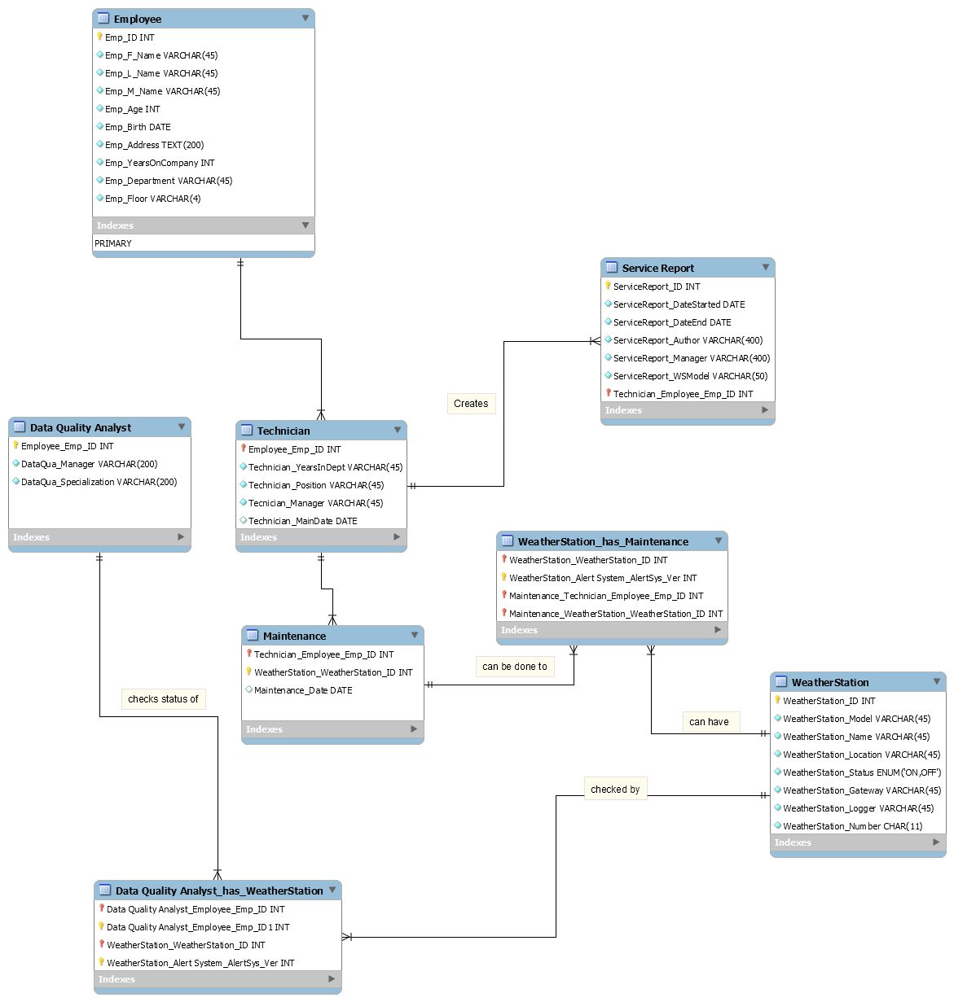

## Figure 1. *Entity Relationship Diagram (ERD)*

This Entity Relationship Diagram (ERD) explains the Database Structure of system.

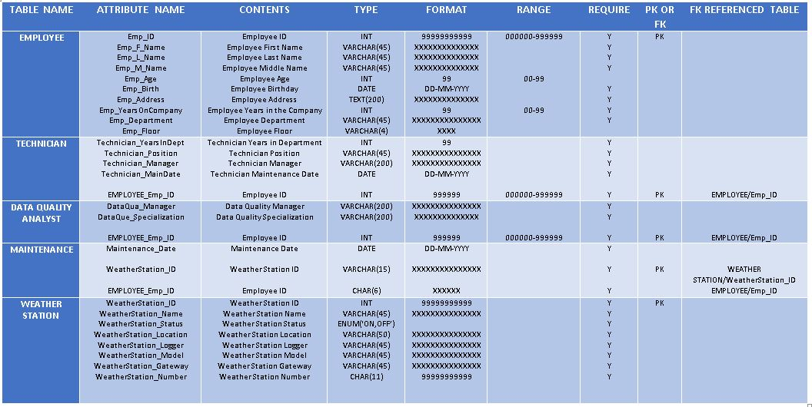

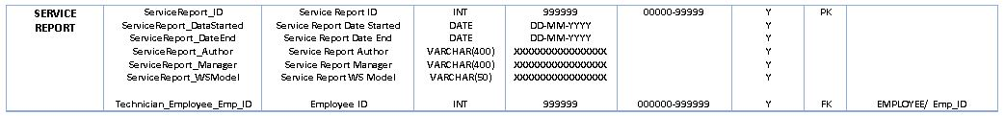

## Figure 2. *Data Dictionary*

*This Data Dictionary shows the attributes and its information as presented in the ERD Diagram.*

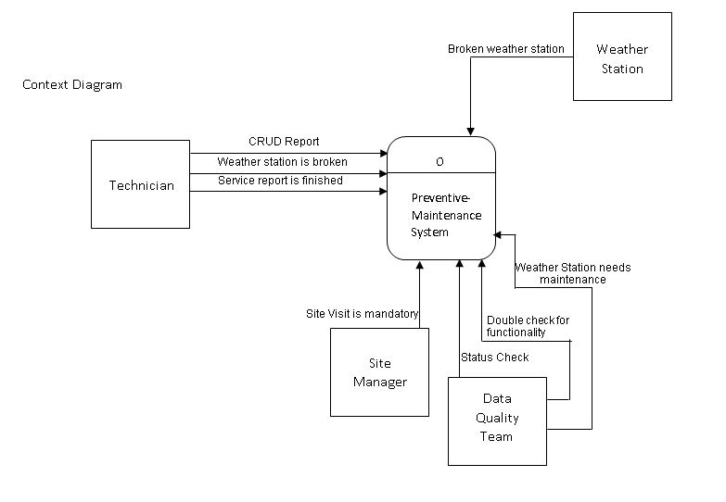

## Figure 3. *Context Diagram*

*This diagram that defines the each boundary between the system and its part.*

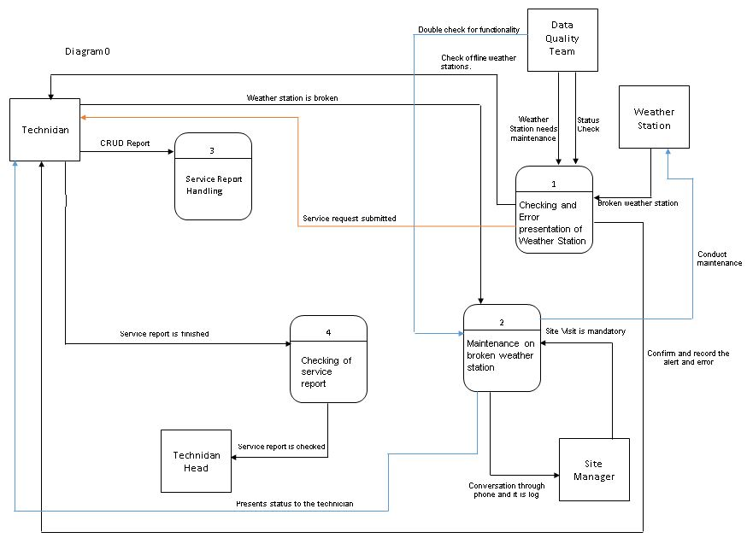

### Figure 3.1. *Diagram 0*

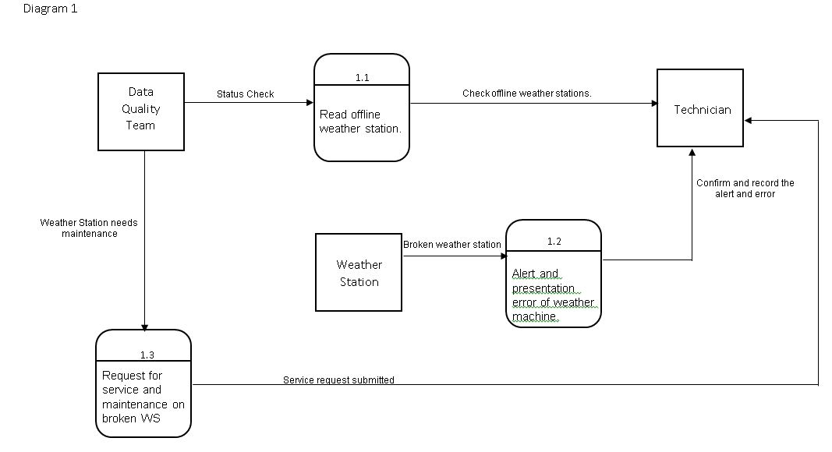

### Figure 3.2. *Diagram 1*

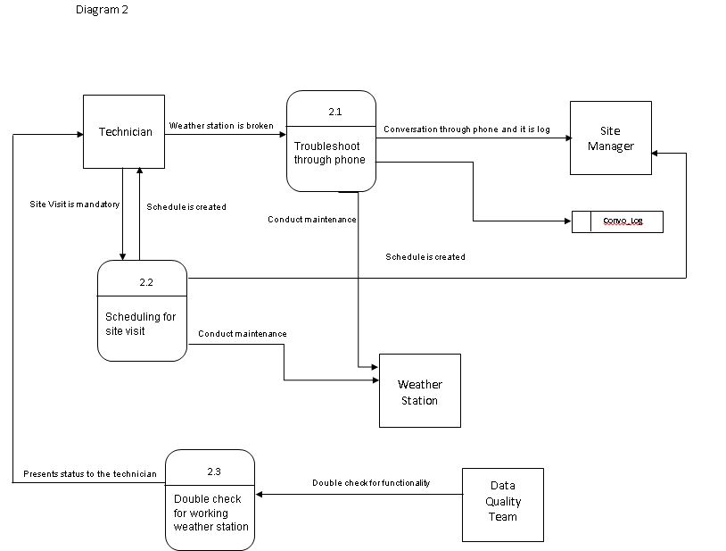

### Figure 3.3 *Diagram 2*

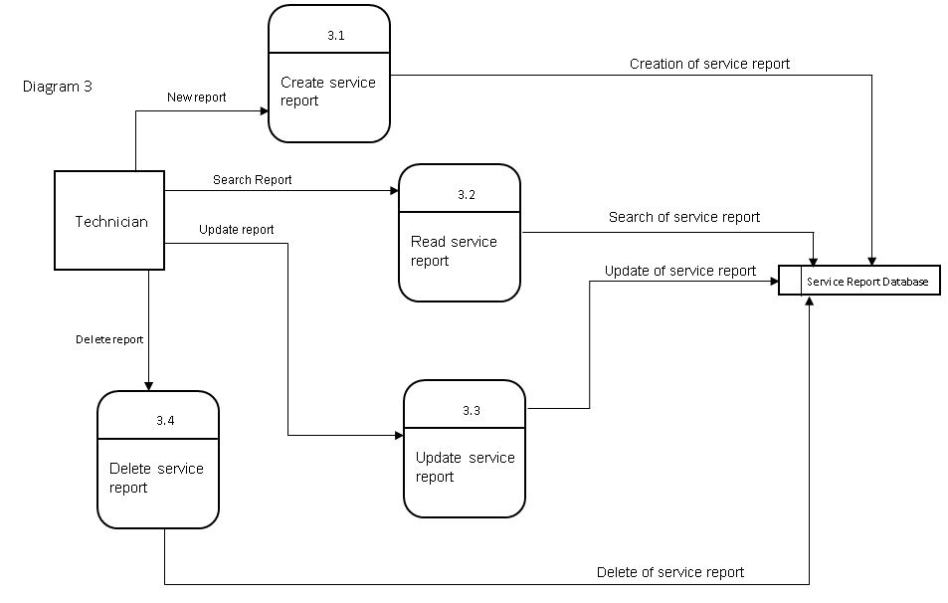

### Figure 3.4. *Diagram 3*

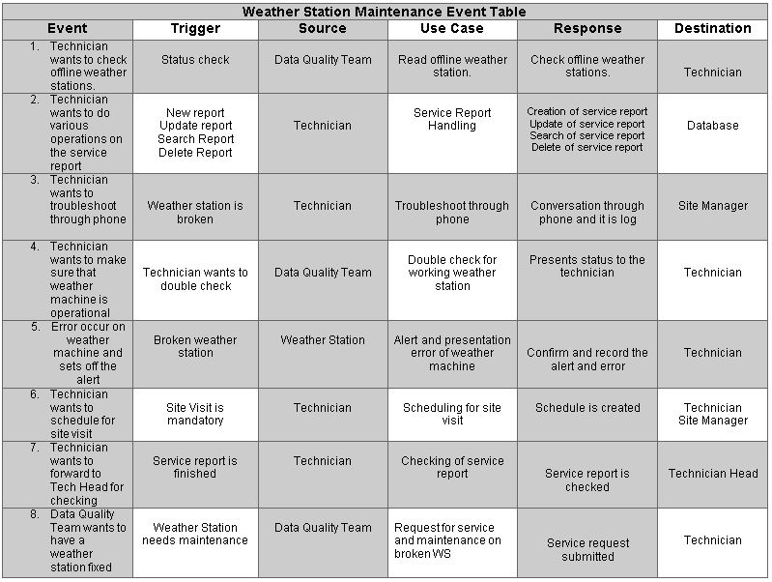

## Figure 4. *Event Table*

*This table shows the data about the log files for each scenario in the system. This is also designed for the use case of the system to obtain.*

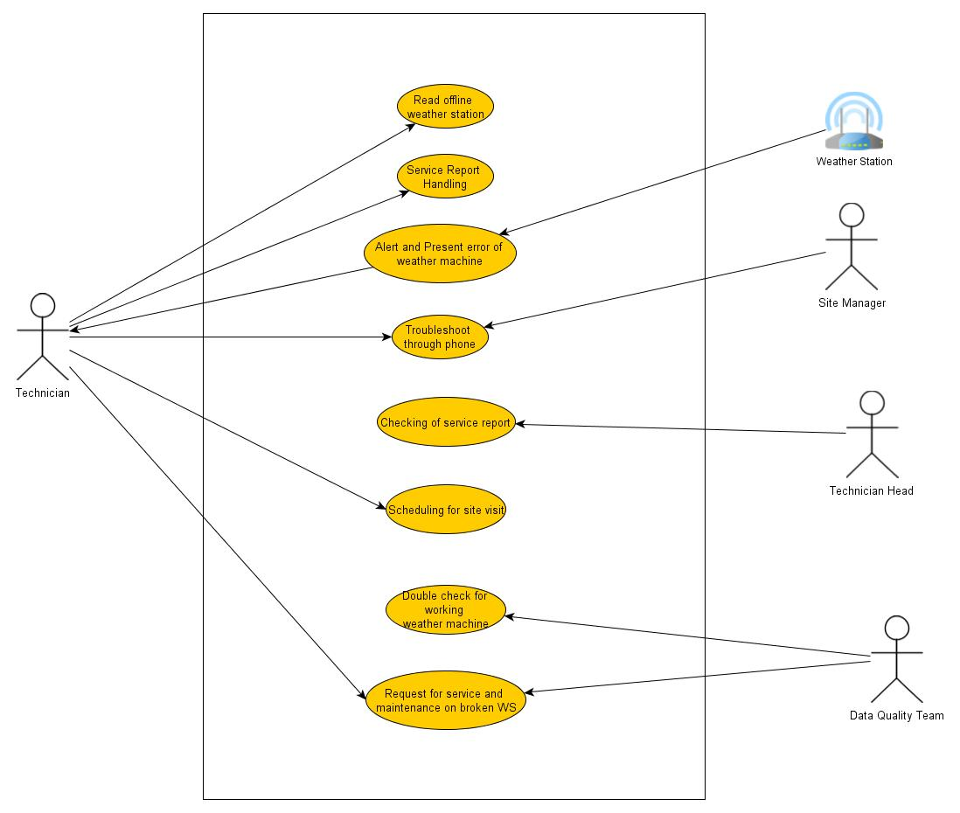

## Figure 5. *Use Case*

*These are the list of event steps of the system based on the Event Table.*

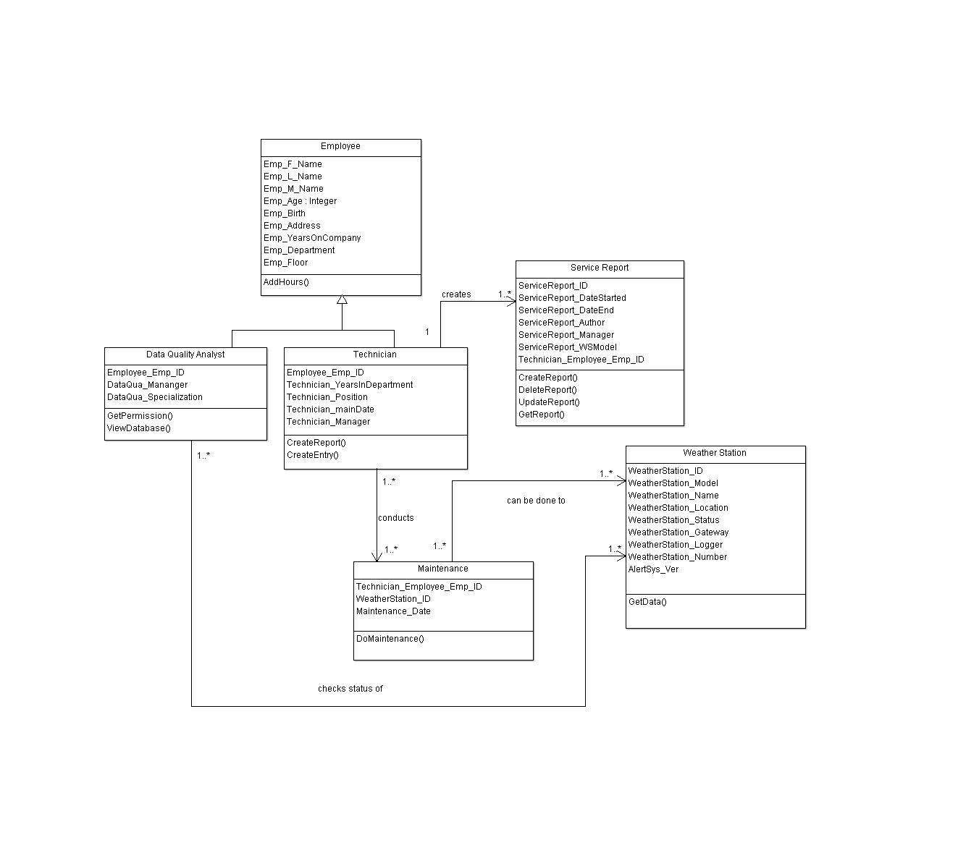

## Figure 6. *Class Diagram*

*This diagram describes the classes of the system with their attributes and methods.*

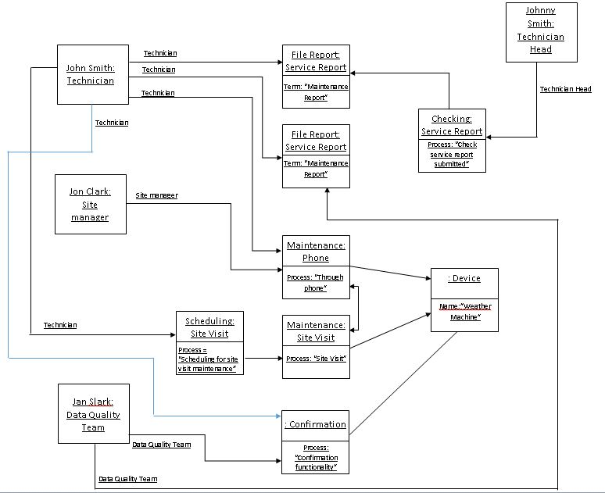

## Figure 7. *Object Diagram*

*This is based on the Class Diagram which shows the detailed state of a system.*

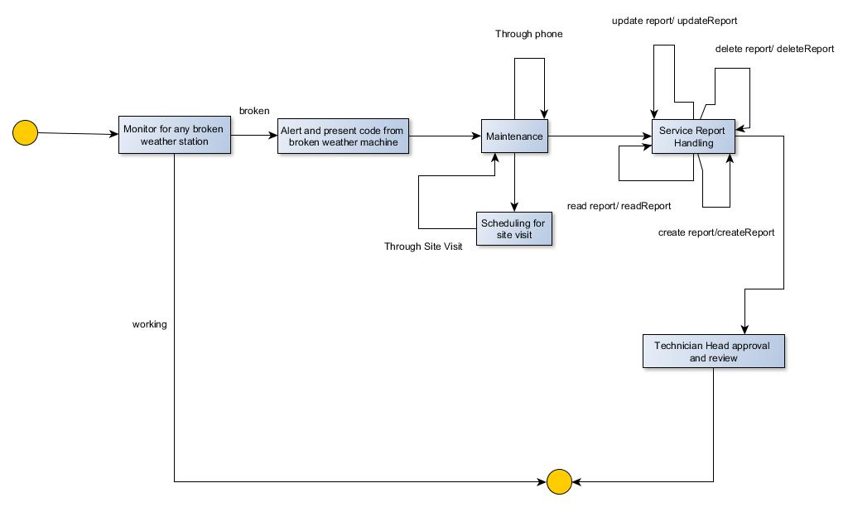

## Figure 8. *State Diagram*

*This diagram presents the behaviour and the processes of the system.*

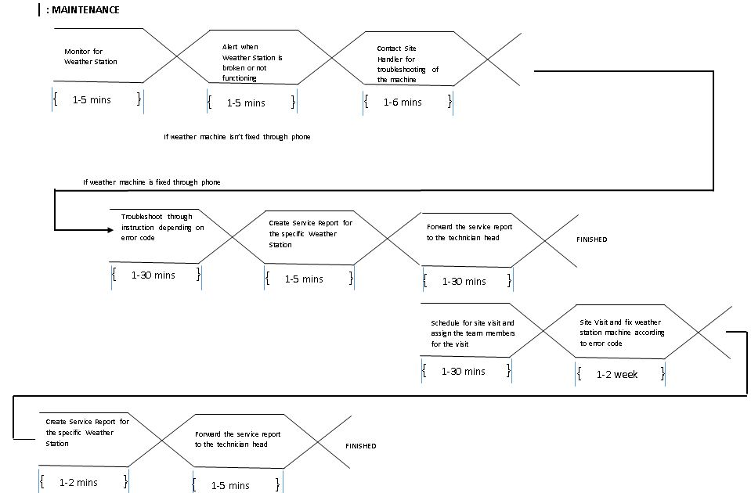

## Figure 9. *Timing Diagram*

*This is the representation of the domain time of the running system.*

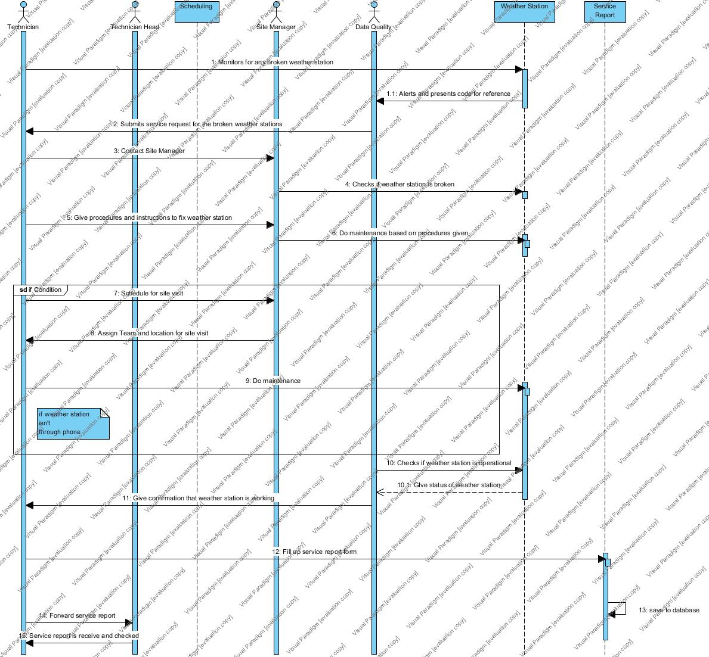

## Figure 10. *Sequence Diagram*

*This diagram shows how objects of the system operates to the other actors.*

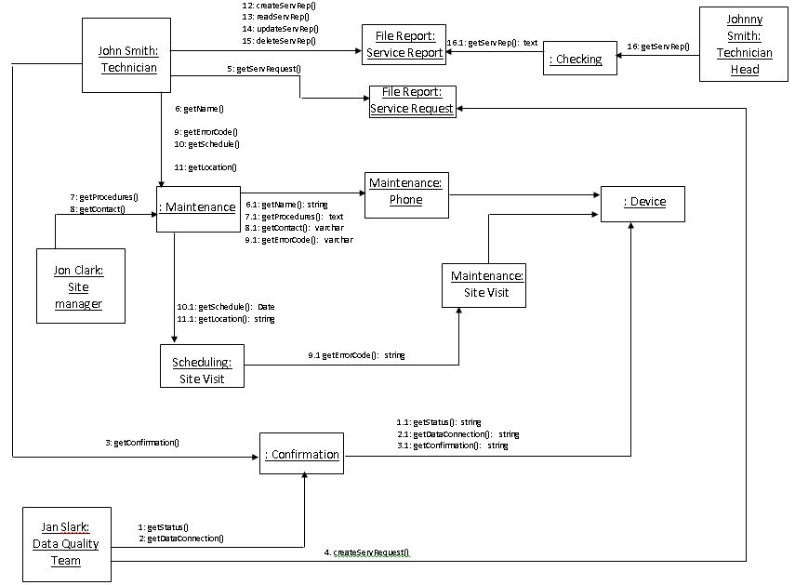

## Figure 11. *Communication Diagram*

*This represents the interaction of the objects with the other actors.*

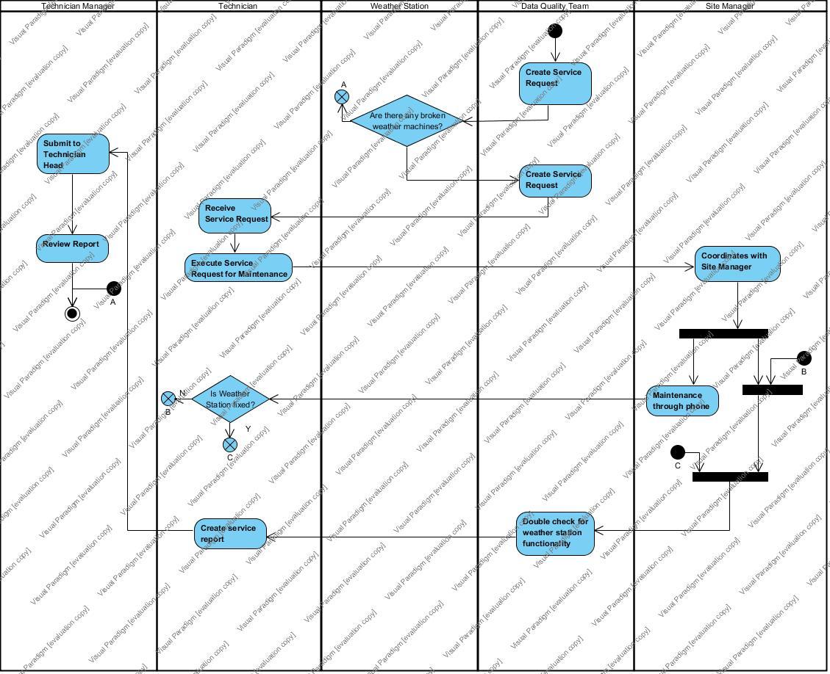

## Figure 12. *Activity Diagram*

This portrays the flow of the activities of the system.

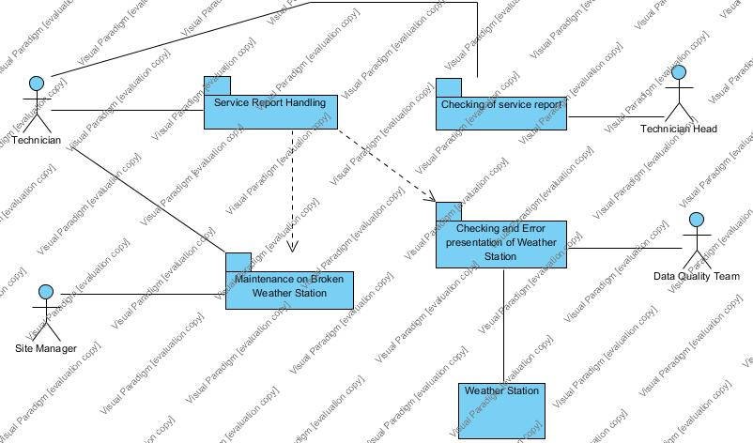

## Figure 13*. Package Diagram*

*This diagram serves as the arrangement of the elements of the system.*

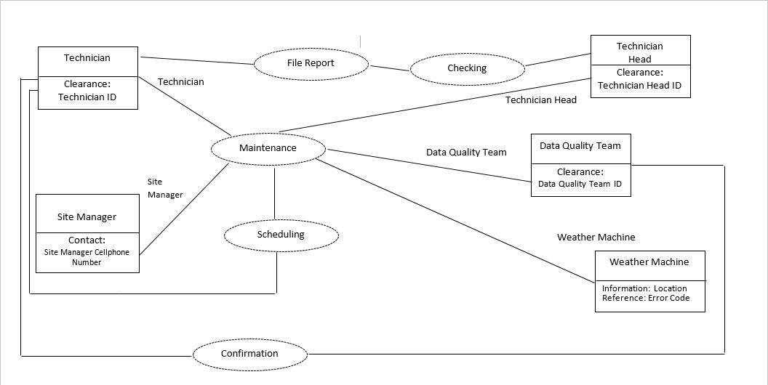

## Figure 14. *Composite Diagram*

The diagram shown act as the internal structure of the system.

**Figure 15. Use Case Fully Developed**

|  |  |  |
| --- | --- | --- |
| **Use Case Name:** | Read offline weather station | |
| **Scenario:** | Read list of offline weather station | |
| **Triggering Event:** | Status check | |
| **Brief Description:** | When the technician is required to see if any of the weather stations is offline, he must do a status check of the weather stations to acquire a list of offline weather stations. | |
| **Actors:** | Data Quality Team | |
| **Related Use Cases:** | Alert and presentation error of weather machine | |
| **Stakeholders:** | Data Quality team: to check the upload and download of the data of the weather stations  Operations and Maintenance department: to apply maintenance for the weather stations to be operational again | |
| **Preconditions:** | Weather station must exist  Alert System must be functional | |
| **Post Conditions:** | Alert System warns technician of down or non-functional weather stations | |
| **Flow of Activities:** | Actor | System |
| 1. The technician goes to the application and enters his login information 2. He navigates to the weather stations status page 3. The Technician analyzes the statuses 4. The Technician lists down the weather station statuses | * 1. System asks for authentication   2.1 Displays the status information |
| **Exception Conditions:** | If user has no account, redirect to sign up page | |

|  |  |  |
| --- | --- | --- |
| **Use Case Name:** | Service Report Handling | |
| **Scenario:** | Technician want to use the operation on the files of service report | |
| **Triggering Event:** | New Report, Update Report, Search Report, Delete Report | |
| **Brief Description:** | The Technician is the one who has access to the service report handling process and it contains the following operations on the files; Create, Read, Update, Delete | |
| **Actors:** | Technician | |
| **Related Use Cases:** | Troubleshoot through phone  Scheduling for site visit | |
| **Stakeholders:** | Operations and maintenance department: to be able to analyze the information of the weather stations for repair or maintenance | |
| **Preconditions:** | Technician must exist.  Database must be up and present.  Weather stations must exist. | |
| **Post Conditions:** | Service report must be created.  Database must receive the service report. | |
| **Flow of Activities:** | Actor | System |
| 1. Technician accesses the service report handling process 2. Picks the following: Create, Read, Update, Delete   For Create:   1. Technician must create a new service report 2. Technician enters the required data for it to be processed. 3. Technician verifies if data is correct. 4. Technician saves the service report file 5. Service report is sent and saved in the database   For Read:   1. Technician enters keywords to search for specific weather station. 2. Technician analyzes the list of the queried service reports. 3. Technician selects the desired service report.   For Update:   1. Technician locates the existing service report to be updated through search 2. Technician changes the information that needs to be updated. 3. Technician saves the report   For Delete:   1. Technician selects the desired service report to be deleted. 2. Technician confirms and validates if the selected service report is to be deleted | 1.1  3.1 Display required fields for service report  4.1 Prompts a message that asks if input data is correct.  6.1 Saves file   * 1. Commits if saved   3.1 Searches the database for the corresponding keywords  5.1 Displays the service report   * 1. Locate the report file   4.1 System displays the service report with fields  5.1 Commits the updated service report.   * 1. Displays service report   4.1 Prompts message asking if he is sure he wants to delete the service report. |
| **Exception Conditions:** |  | |

|  |  |  |
| --- | --- | --- |
| **Use Case Name:** | Alert and presentation error of weather machine | |
| **Scenario:** | Error code is recorded and presented. | |
| **Triggering Event:** | Error occurred from the weather machine; ex. Connection lost or malfunction | |
| **Brief Description:** | Error code is stated and presented for easier reference for the solution | |
| **Actors:** | Weather Station  Technician | |
| **Related Use Cases:** | Troubleshoot through phone  Scheduling for site visit | |
| **Stakeholders:** | Operations and Maintenance Department: to determine what went wrong in the weather machine | |
| **Preconditions:** | Error must occur  Error code is within the ruling of the error codes | |
| **Post Conditions:** | Error code is presented | |
| **Flow of Activities:** | Actor | System |
| 1. Technician checks for any error from weather station 2. Weather station malfunctions | * 1. Alerts technician and error code is presented to the Technician for easier reference |
| **Exception Conditions:** | If error code is not presented, contact site manager for troubleshooting | |

|  |  |  |
| --- | --- | --- |
| **Use Case Name:** | Troubleshoot through phone | |
| **Scenario:** | Weather Station is broken and maintenance through the phone is the first solution to try | |
| **Triggering Event:** | Weather Station is broken or malfunctioning | |
| **Brief Description:** | Technician contacts Site manager so that they can troubleshoot and fix the Weather Station through the phone | |
| **Actors:** | Technician  Weather Machine  Site Manager  Data Quality Team | |
| **Related Use Cases:** | Scheduling for site visit | |
| **Stakeholders:** | Operations and Maintenance Department: to serve as a first solution before a site visit | |
| **Preconditions:** | Technician must have number of the site manager  Information about the weather station must be correct  Site Manager must respond | |
| **Post Conditions:** | A conclusion will be selected, either fix or needs to have a site visit  Call of the site manager and technician must be recorded for history | |
| **Flow of Activities:** | Actor | System |
| 1. Weather Machine is broken 2. Technician calls the Site Manager for maintenance 3. Site Manager answers the call 4. Technician gives the procedures to fix the broken Weather Machine 5. Site Manager applies the maintenance 6. Confirmation from Site manager is given to the technician   If fixed:   1. Data Quality is called to double check if the weather machine is operational   If not fixed:   1. Site Visit is scheduled | 1.1 Alert System is triggered   * 1. Error Code is presented to the technician   3.1 Call is being recorded from the start of the phone being picked up by the Site Manager  4.1 Displays the steps to fix the error through reference of the error code  6.1 Confirmation is recorded  7.1 Scheduling process takes over |
| **Exception Conditions:** |  | |

|  |  |  |
| --- | --- | --- |
| **Use Case Name:** | Double check for working weather machine | |
| **Scenario:** | Maintenance is applied to the weather machine | |
| **Triggering Event:** | Maintenance is done to the weather machine and technician contacts the data quality team | |
| **Brief Description:** | This process is to make sure that the weather station is functioning | |
| **Actors:** | Technician  Data Quality Team | |
| **Related Use Cases:** | Troubleshoot through phone | |
| **Stakeholders:** | Operations and Maintenance Department: to determine if weather station is fixed through maintenance | |
| **Preconditions:** | Maintenance must be done  Weather Station must exist | |
| **Post Conditions:** | Weather Station status is presented | |
| **Flow of Activities:** | Actor | System |
| 1. Technician contacts the data quality team 2. Data quality team answers the phone 3. Data quality team checks the weather machine and gives confirmation whether weather machine is functioning | 1.1 Call is recorded for history and information  3.1 weather machine status is presented  3.2 Confirmation is recorded |
| **Exception Conditions:** |  | |

|  |  |  |
| --- | --- | --- |
| **Use Case Name:** | Scheduling for site visit | |
| **Scenario:** | Maintenance through site visit is needed | |
| **Triggering Event:** | Maintenance through site visit is mandatory since maintenance through the phone didn’t work | |
| **Brief Description:** | This process is for scheduling for the site visit of a weather station for maintenance. Handles the dates and the people needed for the site visit | |
| **Actors:** | Technician | |
| **Related Use Cases:** | Troubleshoot through phone | |
| **Stakeholders:** | Operations and Maintenance Department: to make a scheduling for a site visit more convenience and have a quick process | |
| **Preconditions:** | Troubleshoot through phone method didn’t work  Location is needed | |
| **Post Conditions:** | Schedule is created and a team of technicians is selected | |
| **Flow of Activities:** | Actor | System |
| 1. Technician makes a schedule for site visit 2. Technician wants to select the available people for the site visit 3. Technician selects the dates and the technician for the site visit 4. Technician confirms the schedule | 1.1 Prompts the technician on the date of the site visit  2.1 Presents the technician of the availability of the people in the department  3.1 Confirmation of the schedule is presented |
| **Exception Conditions:** |  | |

|  |  |  |
| --- | --- | --- |
| **Use Case Name:** | Checking of service report | |
| **Scenario:** | Checks the service report submitted | |
| **Triggering Event:** | Service report is finished | |
| **Brief Description:** | When the service report that has been accomplish by the technician is to be checked by the technician head | |
| **Actors:** | Technician  Technician Head | |
| **Related Use Cases:** | Service Report Handling | |
| **Stakeholders:** | Data Quality team: to check the submitted service report if all the forms are correct and filled up. After checking it is uploaded to the database | |
| **Preconditions:** | Technician Head must exist  Form must be filled up | |
| **Post Conditions:** | Service report is reviewed and saved to the database | |
| **Flow of Activities:** | Actor | System |
| 1. Technician finishes the service report 2. Technician forwards the report to the technician head 3. Technician head receives and reviews the service report 4. Technician head saves the files to the database | * 1. System checks if all forms are filled up   2.1 System sends service report  4.1 System saves the service report to the database |
| **Exception Conditions:** |  | |

|  |  |  |
| --- | --- | --- |
| **Use Case Name:** | Request for service and maintenance on broken WS | |
| **Scenario:** | Requesting for maintenance when weather station is broken | |
| **Triggering Event:** | Weather Station needs maintenance | |
| **Brief Description:** | Data Quality Team files a service request to be given to the technicians for the maintenance of the broken Weather Station | |
| **Actors:** | Data Quality Team  Technician | |
| **Related Use Cases:** | Read offline weather station.  Alert and presentation error of weather machine. | |
| **Stakeholders:** | Data Quality team: to file a service request for maintenance. Faster reaction time for the O & M Department for the needed maintenance  Operations and Maintenance department: to determine what weather stations are needed to be fixed | |
| **Preconditions:** | Weather station must exist  Service Request exist | |
| **Post Conditions:** | Service Request is given to the technicians | |
| **Flow of Activities:** | Actor | System |
| 1. Data Quality Team files a service request 2. Fills up all the fields presented 3. Ready to be submitted to the Technicians 4. Data Quality Team submits the service request to the technician 5. Technician receives the service request | 1.1 System presents a form of a service request  3.1 System checks if the fields are correct  4.1 System forwards the service request to the technicians |
| **Exception Conditions:** | If some fields are empty, prompt the user to input the data of the service request | |

|  |  |  |
| --- | --- | --- |
| **Use Case Name:** | Request for service and maintenance on broken WS | |
| **Scenario:** | Requesting for maintenance when weather station is broken | |
| **Triggering Event:** | Weather Station needs maintenance | |
| **Brief Description:** | Data Quality Team files a service request to be given to the technicians for the maintenance of the broken Weather Station | |
| **Actors:** | Data Quality Team  Technician | |
| **Related Use Cases:** | Read offline weather station.  Alert and presentation error of weather machine. | |
| **Stakeholders:** | Data Quality team: to file a service request for maintenance. Faster reaction time for the O & M Department for the needed maintenance  Operations and Maintenance department: to determine what weather stations are needed to be fixed | |
| **Preconditions:** | Weather station must exist  Service Request exist | |
| **Post Conditions:** | Service Request is given to the technicians | |
| **Flow of Activities:** | Actor | System |
| 1. Data Quality Team files a service request 2. Fills up all the fields presented 3. Ready to be submitted to the Technicians 4. Data Quality Team submits the service request to the technician 5. Technician receives the service request | 1.1 System presents a form of a service request  3.1 System checks if the fields are correct  4.1 System forwards the service request to the technicians |
| **Exception Conditions:** | If some fields are empty, prompt the user to input the data of the service request | |

**Gantt Chart**

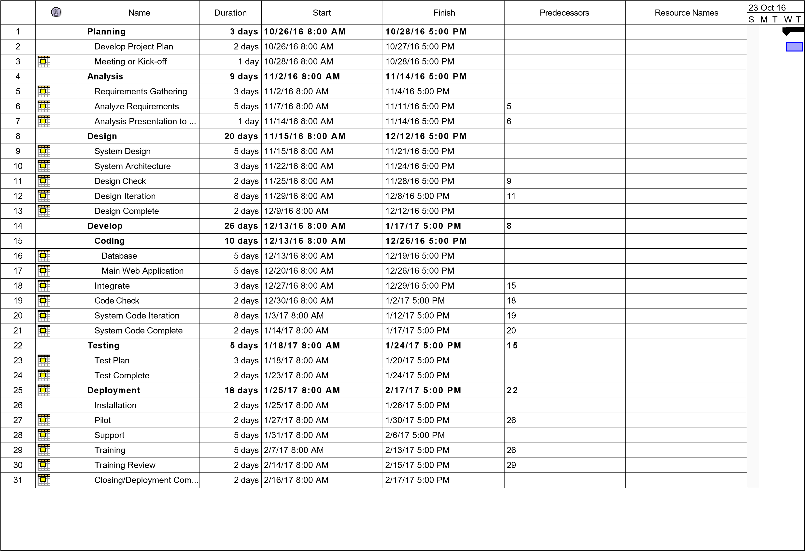

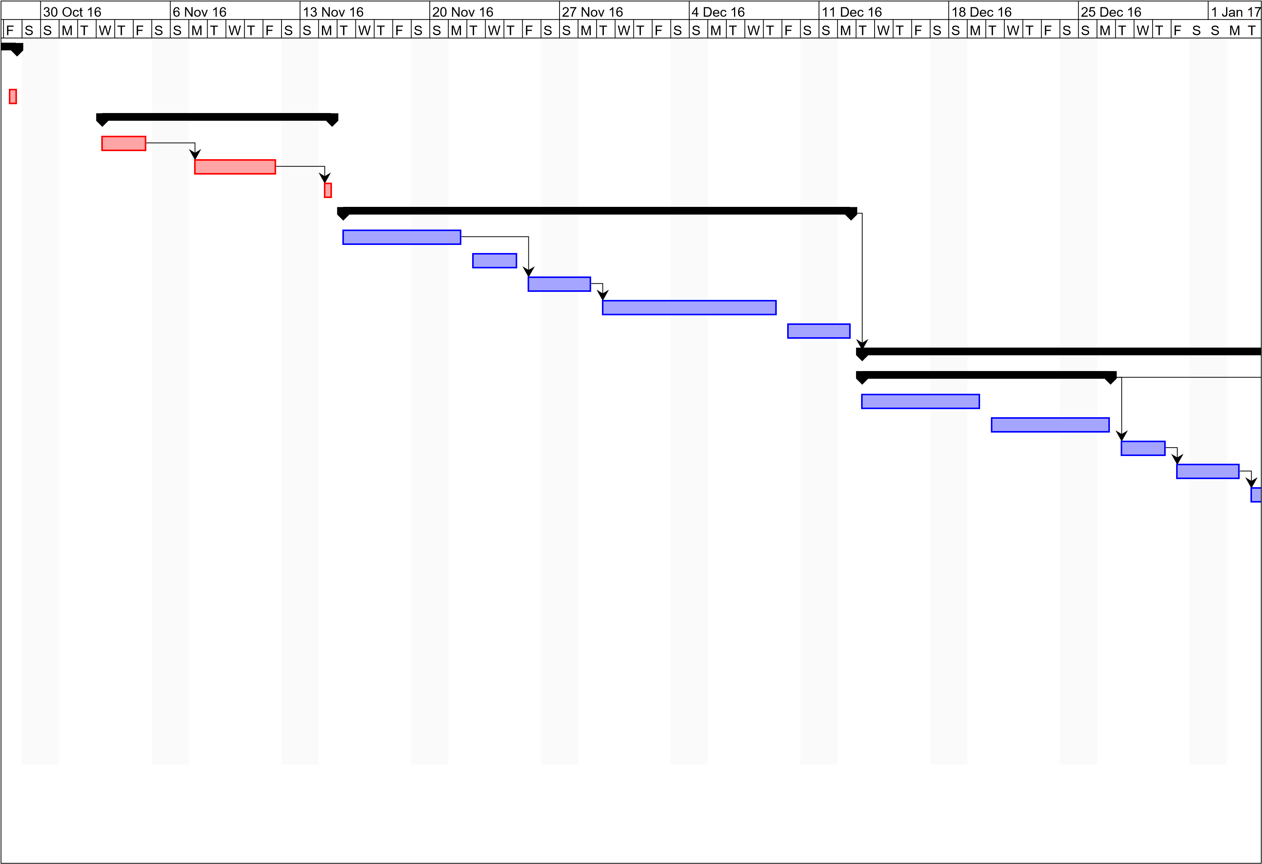

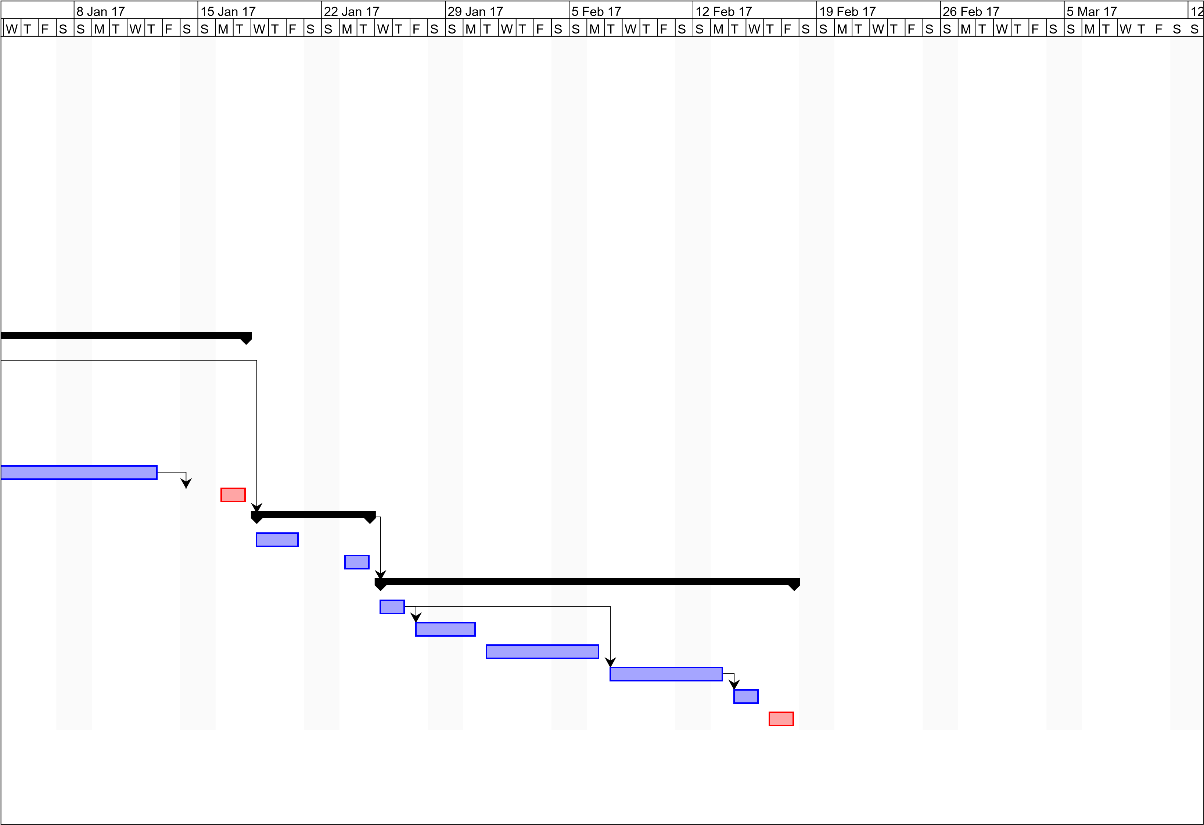

# Statement of Work (SOW)

**Barcode Info**

**by**

**miguel mayor**

**joanna de guzman**

**adrian tobias**

Oct 12, 2016

**Introduction/Background**

The Operations and Maintenance Department of Weather.ph is in need of a major improvement in the system of handling certain data specifically with their weather stations, since the department still utilizes a somewhat primitive method of handling data such as keeping their data in a single spreadsheet file which is shared among the people in the department. With the help of Mr. Adrian Tobias’ and his team of researchers and developers, they will be developing an Asset Management System that includes a web interface that is User Friendly for the administration of the department to use. This software system is important to Operations and Maintenance Department of Weather.ph because of the reliability at which the system will handle data, reducing redundancy of data and organizing the data for quicker access and utilization. The department realizes the importance of proper data management because the information of the weather stations is at the hands of this department.

**Scope of Work**

The scope of work for the WS-AMS includes all planning, execution, implementation, testing and training for the software solution that will replace the existing method. The client would give feedback once the web application or software solution is presented to him. Each stage of the development of this software solution is presented to the client for if there are changes to be made, it is made during the development stage not after the software solution is to be deployed. The client is the final judge if the solution is worthy to use in their department. Specific deliverables and milestones will be listed in the Work Requirements, Schedules, and Milestones sections of this SOW.

There are not included in the scope of work for this project is any problem not related to the scope of this project.

**Period of Performance**

The period of performance for the WS-AMS or Weather Station – Asset Management System is for one year (365 days) beginning on June 26, 2016 to June 27, 2017. All work must be scheduled properly so that there are no delays and the project would be deployed on time

**Place of Performance**

The researchers and developers will conduct most of their work in both Asia Pacific College and at 4624 Iris St. Paranaque, Bicutan City. The researchers and developers will be required to meet twice a week at Asia Pacific College for documentation purposes as well as regular meetings. Also, meetings with the project adviser are done at Asia Pacific College. For work that is extensive and require longer work hours such as web application development, work is done in 4624 Iris St., Paranaque, Bicutan City, due to the allowed longer hours in the area.

**Work Requirements**

As part of the Website Redesign Project the vendor will be responsible for performing throughout various stages of this project. The following is a list of these tasks which will result in the successful completion of this project:

As part of the WS-AMS Project, the researchers and developers will be responsible for performing throughout various stages of this project. The following is a list of these tasks which will result in the successful completion of this project:

Kickoff:

* Researchers will research and find out more about the problem within the Operation and Maintenance department of Weather.ph
* Researchers will create a detailed plan which consist of the following stages: Planning, Development, Testing, Implementation, Recording, and Review.
* Researchers will present the plan to the client for approval

Design Phase:

* Work with client to gather all necessary data and information for the web application
* Create site design based on collected requirements
* Develop site design proposal for client approval and feedback
* Present written status at weekly meeting

Build Phase:

* Researchers will code the designed web application
* Researchers will provide client with a detailed testing plan
* Researchers will update the client weekly on the progress of the web application
* Researchers will include all content provided by client on redesigned web site
* Researchers will conduct testing within a controlled environment
* Researchers will resolve any coding and site issues identified in testing
* Researchers will compile a review for the client to check
* Present written status at weekly meeting

Implementation Phase:

* Researchers will implement the newly redesigned web site on SCG servers
* Researchers will provide a contact list of the following members of this research team for any queries or if any problem should occur, the researchers are easily reached
* Present written status at weekly meeting
* Researchers will provide a manual on how to work the program or how to execute the basic commands for the web application

Training Phase:

* Researchers will guide the technician head on how to use the functionalities of the web application
* Researchers will assist the technicians of the Operations and Maintenance department on how to use the functionalities
* Present written status at weekly meeting

Project Handoff/Closure:

* Vendor will provide SCG with all documentation in accordance with the approved project plan
* Vendor will present project closure report to SCG for review and approval
* Vendor will complete the project requirements checklist showing that all project tasks have been completed
* Vendor will conclude 24x7 web support at 11:59pm on the final day of the period of performance
* Present written status at weekly meeting

**Schedule/Milestones**

The below list consists of the initial milestones identified for the Website Redesign Project:

RFP/SOW Release October 12, 2016

Period of Performance Begins October 16, 2016

Website Design Review October 25, 2016

Website Implementation Review October 30, 2016

Development November 2 – February 26, 2017

Implementation Complete March 26, 2017

Training Complete May 15-20, 2017

Project Completion Review May 27-29, 2017

Project Closure/Archives Complete June 26, 2017

**Acceptance Criteria**

For the WS-AMS the acceptance of all deliverables will be upon the decision of the Operations and Maintenance manager. The manager will create a team of advisers which consist of his following technicians in the same department to check if the web application would meet their standard. They would check if there are any missing features or if there are certain corrections to be made. This is also to ensure if the needed requirements are met. Once every phase is completed, the researchers would contact the client to update them on the progress of the web application.

Once all project tasks have been completed, the software solution will enter the handoff/closure stage. During this stage of the project, the vendor will provide their project closure report and project task checklist to the manager of the Operations and Maintenance department. The acceptance of this documentation by the manager will acknowledge acceptance of all project deliverables and that the researchers has met all assigned tasks from the manager.

Any problems involving completion of project tasks or some disagreement between the client which is the manager of the Operations and Maintenance department and the researchers will be referred to a meeting for review and discussion.

**Other Requirements**

All researchers whom would create WS-AMS will submit the manual of the web application. The manual contains specific steps on how to execute and use the features as well as how to create accounts for accessing the information within the web application. All the members of the research team will be granted access to the client’s database and all necessary IT functions.

All programming and testing will be done in the specific location where in it is stated in the section which is called the “Place of Performance”. That specific location is a controlled environment and after some debugging it would be deployed and implemented in the Operations and Maintenance department.

**Acceptance**

Approved by:

Mr Manuel Sean Sebastian

Professor

December 5, 2016

# Vision and Scope Document

for

Asset Management with Barcode Tagging System for Operations and Maintenance Department of Weather.ph

Version 1.0 approved

Prepared by Miguel Mayor, Joanna De Guzman, Adrian Tobias

Oct. 10, 2016

**Revision History**

|  |  |  |  |
| --- | --- | --- | --- |
| Name | Date | Reason For Changes | Version |
| Adrian Tobias |  |  | V1.1 |
| Miguel Jaime Mayor |  |  | V1.2 |

**Business Requirements**

* The business requirements from the client himself are stated as the following:
* Able to create and schedule dates for maintenance
* Able to update the specific weather stations for the department
* Connectivity to the application and the database is always available
* Barcode tagging is implemented to the system

**Background**

The main problem that the Operations and Maintenance Department of Weather.ph is handling right now is the management of each description and detail of every weather station here in the Philippines and the compilation and creation of service reports for every maintenance executed on the weather stations. The problem is that overlapping of data and the loss of data may occur since the method that they are using right now is Excel for the management of the description of the weather stations and it is sent through email only. Knowing that kind of problem exist, this particular web application solves all the inconsistency that exist in the current system.

**Business Opportunity**

The WS-AMS, or the Weather Station – Asset Management System, should be implemented in the Operations and Maintenance Department because not only the inconsistencies of the current system would disappear but productivity would increase in terms of quick access of the database itself and immediate submission of the service reports. The system would compile all the available data that describes the weather station into one centralized database. The service reports would be compile into the same database for archival purposes and for future backtracking on the previous maintenance done on the weather station. The system is also limited to those who are inside in the Operations and Maintenance Department and as well as having an “Aboitiz” email. Limiting the data to only certain amount of people is a good practice for security.

**Business Objectives and Success Criteria**

The objectives of this certain web application is that to provide easy access to the data and to eliminate the inconsistencies in the current system. In return, more work is accomplished in a shorter time due to the easy access of the information about the weather stations as well as the service reports.

**Customer or Market Needs**

Our system provides the scheduling segment which the user could propose and create a task in a specific date, they could record the information about the specific weather station that they would choose, and service reports could be sent here. Other functions like IM or instant messaging are to be added as well as notifications or alerts for the users for easy communication among the department. The admin would create a new account for the user and once the user is validated, that specific user could access any information that describes the weather station as well as navigation of the scheduling part and the service report archives. This makes accessing data much easier compared before.

**Business Risks**

The biggest risks of creating this application is time itself because it could be created and finished late due to the large functionalities of the program. User acceptance is not an issue because the employees of the Operations and Maintenance Department could easily adapt into a new program to be used in their process of maintenance. The never ending problem that exist in any web application is the attacks from hacker or people with malicious intent that would want to exploit the information inside the web application.

**Vision of the Solution**

**Vision Statement**

The WS-AMS will be able to turn primitive file systems in handling information to a more advanced and modern system for handling data that provides security and organization as well as the implementation of barcoding which improves the rate and speed at which date is transferred. With this system solution, Weather.ph will have a major improvement in data handling for the information of their weather stations.

**Major Features**

Major features included in this system are the following:

* Barcode tagging function that holds the keys to the actual data
* A web application that has a User-friendly UI for simplified use for both admin and normal users
* Web application uses a modernly used framework called Yi framework
* Quick and reliable access to data through a database

**Assumptions and Dependencies**

The researchers and developers of the project assumed that Weather.ph would give the necessary information regarding the weather stations such as weather station name, location, number, etc. It was also assumed that the client would cooperate with us to give us some features he in needs in their department. For the Asset Management with Barcode Tagging System for Operations and Maintenance to succeed, it must maintain a strong business relationship with the Operations and Maintenance department to ensure they will proceed with the system solution. Also, barcoding equipment such as barcode printers and barcode scanners would be needed for the system. Lastly for the system to succeed, the project adviser’s presence throughout the project is needed, from start to end for purposes of consultation and advising.

**Scope and Limitations**

The department that will be using this system is the operations & the maintenance department. The study will not cover other departments such as financial department, Human resources, etc. This system is limited to the operations & maintenance department. This study is also limited to the improvement of the old system by proposing a new software solution, which provides convenience and increase in productivity in the Operations and Maintenance department of the company; it does not focus in other problems in the company. The technology used in this study is limited to Weather station and the proposed software solution as well as the components of the software solution. The features that are included in this web application are the following: Scheduling of the maintenance on-site; Navigation of the information about specific weather stations; Navigation of the service reports generated; IM or instant messaging; Notifications and other functionalities that could be given by the client at a later time. This web application does not have any other functionalities that are not related in solving the inconsistency of the department.

**Scope of Initial Release**

The major features of the application is that the user could execute a CRUD or Create, Read, Update, and Delete operation on the information available. That specific information is about the data which describes each weather station in the Philippines. Other noticeable features are the scheduling capabilities of the web application to reserve or set a specific date for weather station maintenance and navigation through the service report archives.

**Scope of Subsequent Releases**

When the web application is advanced or iterated for another update, there will be an IM or instant messaging functionality in the web application for easier communication among the employees in the department. There will be also a notification capability which should alert the employees of any news or updates coming from the head of the operations and maintenance department.

**Limitations and Exclusions**

The main goal of the web application is to solve the inconsistency existing in the current system and to increase the productivity of the employees in the Operations and Maintenance department. Other problems that the department is facing which is not related to the proposed solution of this web application are not included.

**Business Context**

**Stakeholder Profiles**

|  |  |  |  |  |
| --- | --- | --- | --- | --- |
| **Stakeholder** | **Major Value** | **Attitudes** | **Major Interests** | **Constraints** |
| *Technician* | *Increase in productivity* | *See web application as a way for easy access of data* | *Able to see the information anywhere; accessibility* | *Budget allocation* |
| *Technician Head* | *More work is done* | *See web application as a way to correct inconsistency* | *No more inconsistencies; ease to use;* | *Budget allocation* |
| *Researchers* | *Less error in code and in research* | *Expect to finish the research with the client agreeing with the deliverables* | *Research is done; Web application has no errors* | *Few team members; less time to work with* |

**Project Priorities**

|  |  |  |  |
| --- | --- | --- | --- |
| *Dimension* | *Driver (state objective)* | *Constraint (state limits)* | *Degree of Freedom (state allowable range)* |
| *Schedule* | *Release of 1.0v in the end of CSPROJ* | *Short time period* | *90%-100% of web application should be finished* |
| *Features* | *Release of 1.0 with the functionalities and features working properly* | *Maximum of 4 features as of now* | *70-80% of high priority features must be included in release 1.0* |
| *Quality* | *Manageable web application and easy to use* | *First release of the software; expect bugs and error* | *80-95% of user acceptance* |
| *Staff* | *Cooperation for the completion of the software solution* | *maximum team size is 6 developers + 4 testers* | *95%-100% team coordination and 100% completion of the solution* |
| *Cost* | *Stay within budget without spending more than the minimum budget* | *Minimum budget* | *budget overrun up to 15% acceptable without executive review* |

**Operating Environment**

The web application is built using PHP language as well as other web oriented languages like HTML, Java script, etc. The users are inside the office but when they are performing maintenance on a weather station, they are at that designated location of that specific weather station. Only maximum 2 people are going to that specific location whenever maintenance is needed. The system is accessible through the internet. Data is generated when the user needs to update the information about the weather station. They also generate information in terms of service reports from the maintenance they had executed.

**Software Requirements**

**Specification**

**for**

**Asset Management with Barcode Tagging System**

**Version 1.0 approved**

**Prepared by Joanna De Guzman, Adrian Tobias, Miguel Mayor**

**Nov. 11, 2016**

**Revision History**

|  |  |  |  |
| --- | --- | --- | --- |
| **Name** | **Date** | **Reason For Changes** | **Version** |
|  |  |  |  |
|  |  |  |  |

**1. Introduction**

**1.1 Purpose**

The purpose of this Software Requirement Specification, or SRS, is to give an in-depth and detailed description of what is needed for the Asset Management System for Maintenance Department of Weather.ph. This will show what the purpose of the software, as well as the development of the system software itself. This will also reveal constraints of the system, Interface Requirements, and System Features.

**1.2 Document Conventions**

* CRUD – stands for Create, Read, Update, Delete. Create means to make a record, read lets the user view the record, update allows the user to modify the record, and delete, as the name implies, lets you remove the record.
* MySQL Database - an open source RDBMS, or relational database management system, that is a software which holds the data and any information that comes from users.

* Attributes – The headers of the tables that label the different data. E.g. Employee Table has an attribute called *firstName* which is the first name of the employee.
* Tables – Specific group that holds information about a subject. E.g. Employee Table contains the records of the employees.

**1.3 Intended Audience and Reading Suggestions**

This SRS is intended for the developers of the Asset Management System, specifically the project manager, the systems analyst/systems developer, and the project researcher. Also, it will be relevant for the Head Technician of the Operations and Maintenance department of Weather.ph to read this SRS.

**1.4 Product Scope**

The Asset Management System for the Operations and Maintenance department of Weather.ph is a web-based application that implements a CRUD module to allow the creation, readability, update, and deletion of service reports and information of the weather stations. This Asset Management System also includes a barcode tagging function that allows easy access of the information of the weather station itself. As stated earlier, this software system is limited to only the Operations and Maintenance Department of Weather.ph.

The Asset Management System will include a web application that consists of a frontend and a backend. The frontend will display basic website information such as a home screen, about page, and a login page. The backend will consist of functions only accessible to those who have an Administrator account. These functions include CRUD modules for service reports, weather stations, and privilege management.

**1.5 References**

Yii 2 Documentation – Accessible through the internet; Link: http://www.yiiframework.com/doc-2.0/guide-index.html

Main Paper Documentation - Accessible through the internet; Link: http://projects2.apc.edu.ph/wiki/index.php/Project_-_Barcode_Info_-_113

**2. Overall Description**

**2.1 Product Perspective**

The origin of the web application came from the suggestion of the client to replace the existing system that is being used today. The current system, an excel file holding all the data, is already obsolete in terms of availability and consistency. The web application, which would replace the existing system, contains specific functionalities that the current system cannot provide.

**2.2 Product Functions**

The functionalities of the web application are the following:

* Service Report, Weather Station, Event Create, Read, Update, Delete (CRUD)
* Event calendar and schedule
* Barcode implementation
* User level management

**2.3 User Classes and Characteristics**

There are two types of user level, Advance and Normal. These two types of user levels separate the privilege use of the CRUD operation on the data provided. The Advance user has full CRUD functionality on the Service Report and Weather Station entries while the Normal user cannot use the update and delete functionality. These user levels are granted by the admin and the admin only holds the power to change, create and delete a user’s level. A user without any type of user level would not be able to access any page unless that user is given a user level.

**2.4 Operating Environment**

The web application is currently being hosted by XAMPP Apache’s server and the database being used is a MySQL database. If the construction of the functionalities reach 80% (currently 60%), the web application would be integrated to Bluemix for hosting purposes. The hardware needed to access the web application is a normal computer with access to the internet.

**2.5 Design and Implementation Constraints**

Security considerations and implementations on the web application is to be added after the web application is finished. The functionalities of the web application are prioritized first per request of the client. The barcode phone scanner implementation would also be affect due to the barcode phone scanner is another system entirely.

**2.6 User Documentation**

A user manual will be created to guide the new users on how to use the web application. This would cover steps on how to create weather station entries as well as service report entries. Other functions like event creation and view is also covered in the user manual.

**2.7 Assumptions and Dependencies**

The issues around the operating environment is that it cannot be accessed through the internet. The web application is still hosted locally in a computer. This would limit the access of the proposed users to use the system.

**3. External Interface Requirements**

**3.1 User Interfaces**

The first screen that should be visible is the Home Page which displays a “Welcome!” Header that includes several links leading to Admin Login page, About page, and the Contact Page. There is also a navigation bar at the top of the webpage (Figure 1).

When you click the Login webpage, a login page will appear. If you are an admin, you will be able to enter the required information for you to access the Service Report page, Privilege Management page, and the Weather Station page. Otherwise, the only accessible pages are the Home page, Contact page, Signup page, and the Login page (Figure 2).

The About page contains brief information about the company, Weather.ph, as well as some logos of the partners (Figure 3).

The Contact page is where the user can send business inquiries or other questions by filling up a form and sending it to the company (Figure 4).

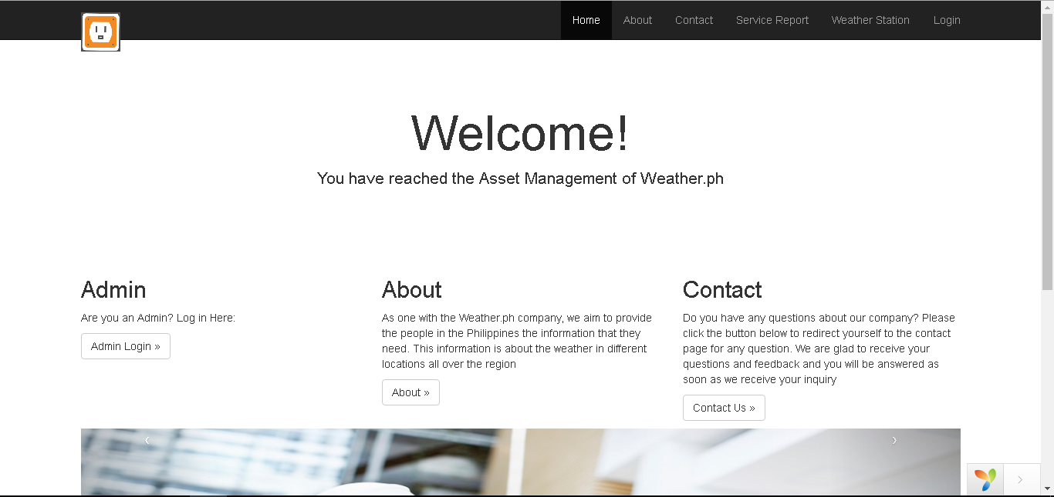

*Figure 1. Home page*

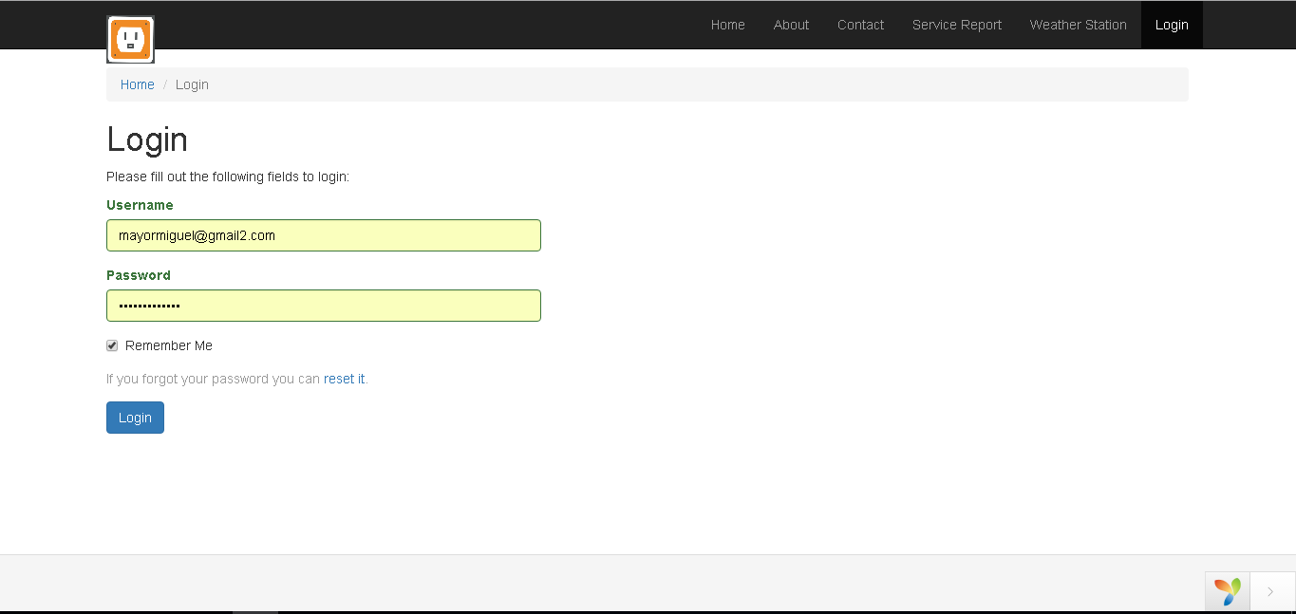

*Figure 2. Login Page*

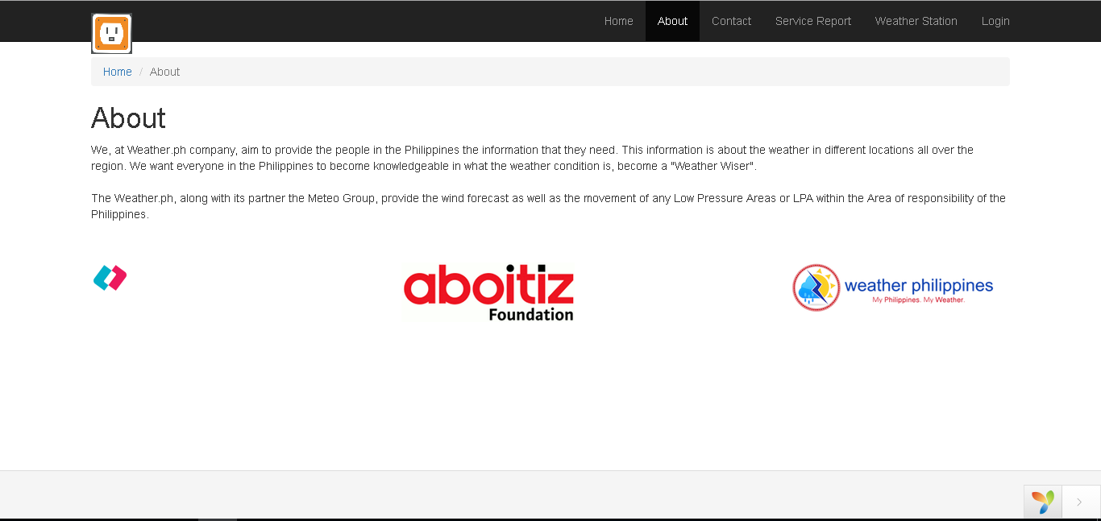

*Figure 3. About Page*

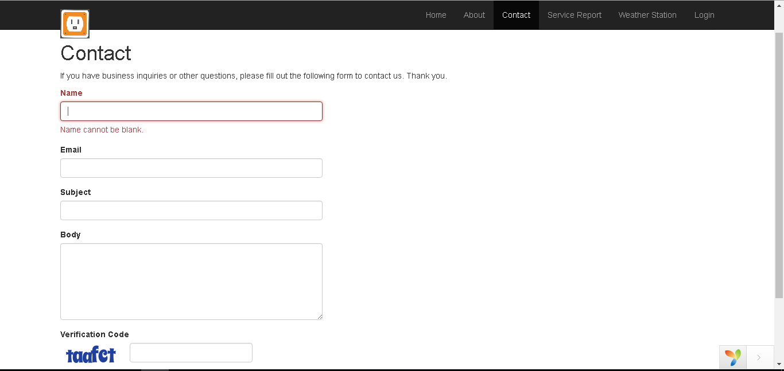

*Figure 4. Contact Page*

*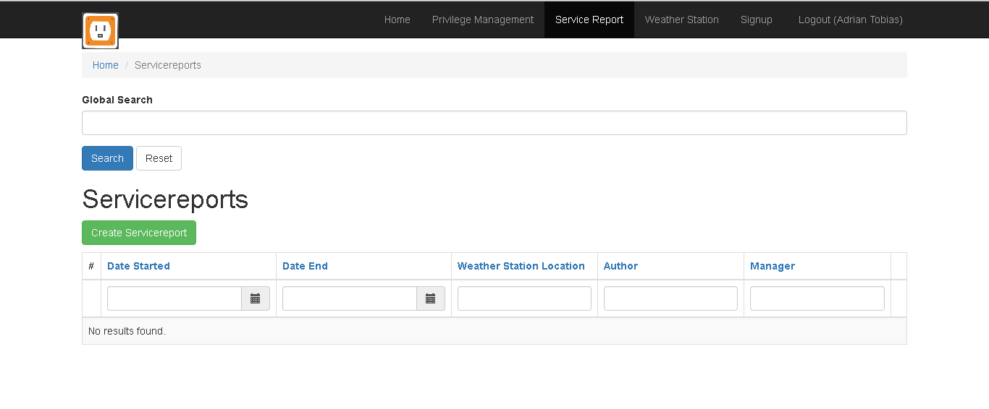Figure 5. Service Report Page*

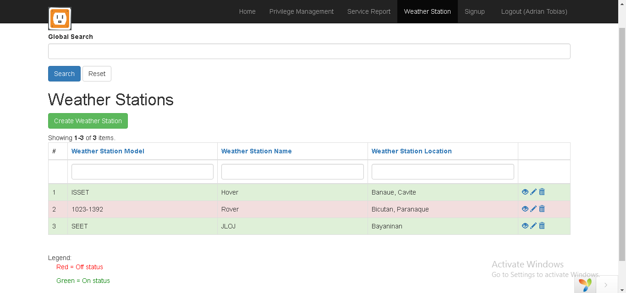

*Figure 6. Weather Station Page*

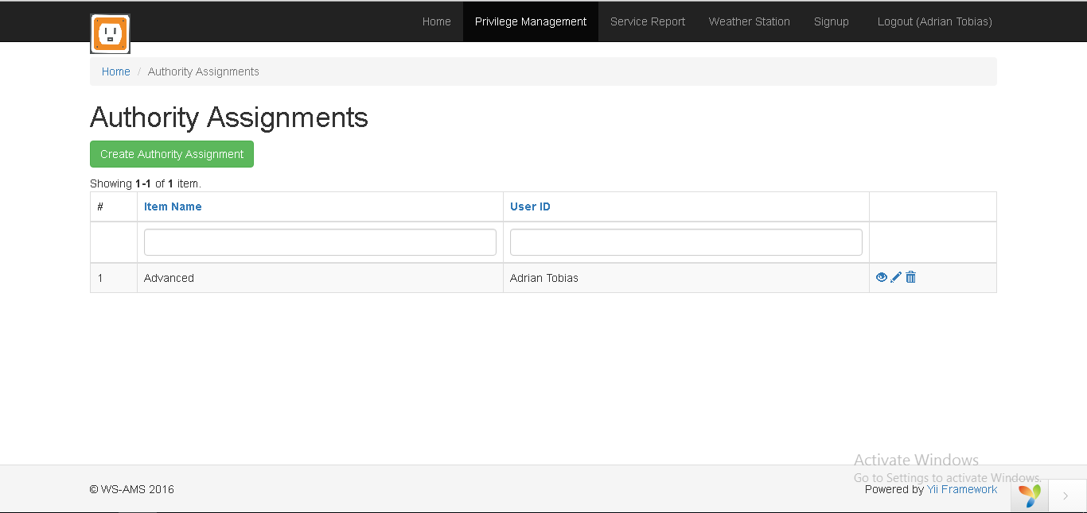

*Figure 7. Privilege Management Page*

**3.2 Hardware Interfaces**

The devices that can run the web application is any tablet device, cellphone, and computer device that has internet access. The database server connection is managed through the hosting of the Apache server in the localhost computer

**3.3 Software Interfaces**

The web application connects to the database for the manipulation of data. Each session of the web application could view and manipulate the data in the database, either using phone, tablet, or computer as a medium. All functionalities are presented per the screen size and everything is adjusted after opening the web application itself

**3.4 Communications Interfaces**

To access or to communicate with the web application, the user needs to access the web application through the web browser. The communication standards that it would use is the HTTP, TCP and the IP standard. The data transfer rates from the user to the server depends on the speed of the internet. If 1Mbps speed is attainable, it is possible for the transfer rate upload to be at 100kb/s. One security risk that the web application is cross site scripting and unauthorized access to the web application.

**4. System Features**

**4.1 Event Scheduling**

**4.1.1 Description and Priority**

This feature has a high priority since the client stated that they want this type of feature because if this feature is a part of the system, it would be much easier to handle the people who will execute the maintenance on site. The benefit of this feature is that when implemented, the client and the other workers would have an easier access to the schedule of the event coming up this week or this month. The risk of not completing this feature is that the client would stick to the current system of scheduling which is assigning jobs through email

**4.1.2 Stimulus/Response Sequences**

The feature starts with the head technician creating a maintenance event date or any type of event. This would let the system prompt the head technician when is the start date and end date as well as the people who are to be assigned to the event. The people assigned are then notified that they have a specific task coming up. The system would display all the event either by month or by week.

**4.1.3 Functional Requirements**

*For Normal User:*

REQ-1: Should have an account to view the event schedule

*For Administrator:*

REQ-1: Should have an admin account. If error occurs, the event would be cancelled and the form is needed to be filled up again for the event to be created.

**4.2 CRUD Operations**

**4.2.1 Description and Priority**

This feature has a high priority since all the operations on the data is on this one operation. The benefit of implementing this feature is that there would be an easier way to check and edit the data and information given. The risk of not having this feature would greatly delay the overall project since the whole project depends on this feature

**4.2.2 Stimulus/Response Sequences**

The feature starts with the head technician or normal user creating either weather station entry or service report entry. The normal user has the power to view and create functionality while the admin has four functionalities: Create, Read, Update, and Delete. The system would depend on the user what to do next.

**4.2.3 Functional Requirements**

*For Normal User:*

REQ-1: Should have an account to view the event schedule and create an entry. If error occurs, present error 403.

*For Administrator:*

REQ-1: Should have an admin account to use all the functionalities of CRUD.

**5. Other Nonfunctional Requirements**

**5.1 Performance Requirements**

The web application of the system must run 24/7, for the administrators to be able to access the website at any given time, in case a need for change is required, or in case a problem has occurred.

The web application itself is not intensive with internet bandwidth, as each Web page’s size is about 40-60KB. The only aspect that would be intensive with internet usage is the feature that the data is real-time, which means that servers have to constantly update the data of the web application.

The web application could be accessed outside the local area network of the company, so that the site administrators could access the website anywhere. No VPN would be required to access the web application. The website must also not be indexed so that it would be unsearchable in search engines (e.g. Google).

**5.2 Safety Requirements**

To mitigate the chances of having data leakage, the user must be aware of his surroundings and keep his password to himself or herself. By not spreading the user’s password, the chance of having unauthorized access could be minimized

**5.3 Security Requirements**

Since the creation of the web application is at a rush, there is security holes involve in the database and the accessing of the pages. Although access control is implemented, there are ways on how to access the pages without being a user. The users could be signed up by the admin and those users need to log on to the system via the frontend part of the page. The security is needed to be upgrade to a standard which is defined by having possible defences against XSS attacks as well as MySQL Injection attacks

**5.4 Software Quality Attributes**

The application should have the following attributes:

* Availability – to have constant access to the data within the web application
* Maintainability – to have a constant run of the web application and to keep it running and avoid it breaking down
* Portability – accessible through any device
* Reliability – having data which is constant and current

These following traits must be observed so that user satisfaction is achieved. Ease of use over ease of learning is observed during the creation of the web application

**5.5 Business Rules**

A normal user could only read and create entry in the service report, weather station and the user could only view the event schedule while the admin has full access to the pages, have the full CRUD functionalities, user creation, and event creation.

**6. Other Requirements**

The requirements for establishing a database is to have the company apply the tables of the web application’s database migrated to their database.

**Appendix A: Glossary**

* CRUD – Create, Read, Update, Delete; standard for any web application
* Error 403 – Common HTTP error. Forbidden access to a certain page
* HTTP - The Hypertext Transfer Protocol (HTTP) is an application protocol for distributed, collaborative, hypermedia information systems. HTTP is the foundation of data communication for the World Wide Web.
* IP - The Internet Protocol (IP) is the method or protocol by which data is sent from one computer to another on the Internet.
* KBps – Kilobytes per second. Used as a unit of speed in terms of data transfer
* MySQL - is an open-source relational database management system
* TCP - The Transmission Control Protocol (TCP) provides a communication service at an intermediate level between an application program and the Internet Protocol
* VPN - A virtual private network (VPN) extends a private network across a public network, such as the Internet. It enables users to send and receive data across shared or public networks as if their computing devices were directly connected to the private network.
* XAMPP - is a free and open source cross-platform web server solution stack package developed by Apache Friends, consisting mainly of the Apache HTTP Server, MariaDB database, and interpreters for scripts written in the PHP and Perl programming languages. XAMPP stands for Cross-Platform (X), Apache (A), MariaDB (M), PHP (P) and Perl (P).
* XSS - Cross-Site Scripting (XSS) attacks are a type of injection, in which malicious scripts are injected into otherwise benign and trusted web sites.

# Quality Plan

**Asset Management with Barcode Tagging System**

**1. Introduction**

This document, together with other referenced documents, defines the responsibilities and procedures to be adopted to ensure that the data and information produced as part of Project 113 are reliable, fit for purpose and consistent with documented objectives and deliverables. It summarises the system of internal management that governs the decisions and instructions concerning project quality assurance.

**2. Project Contractual Information**

|  |  |
| --- | --- |
| Project: | *Asset Management with Barcode Tagging System* |
| Project Number: | 113 |
| Programme Co-ordinator: | Mr. Paulo Oblepias |
| Principal Investigators(s): | *Mr. Manuel Sean Sebatian*  *Asia Pacific College*  *Humabon Place, Magallanes, Makati City* |

**3. Scope of Work and Quality Objectives**

|  |  |
| --- | --- |
| Scope of work: | This would involve in the creation and update of the requested functionalities by the client. The specific functionalities are the following:   * Event Creation * Service Report * Weather Station * Privilege Assessment * Basic Home, Contact and About * Barcode   This would not cover any other functionality that is not stated by the client. |
| QA Requirement: | Quality criteria |

**4. Project Organization**

|  |  |
| --- | --- |
| Project Manager: | *Miguel Jaime Mayor* |
| Task Manager: | *Adrian Tobias* |
| Quality Assurance: | *Joanna De Guzman* |
|  |  |
| Subcontractors: | *Joanna De Guzman* |
| User Community: | *Adrian Tobias* |
| Technical Reviews: | *Paulo Oblepias* |

**5. Project Duration and Scheduling**

|  |  |
| --- | --- |
| Start Date: | 01/04/16 |
| Completion Date: | 1215/16 |
| Scheduling of Activities: | *Gantt chart* |

**6. Deliverables**

Deliverables specified for the project include:

1. An acceptable Quality Plan
2. An acceptable Data Management Plan
3. Software requirements specification
4. Statement of Work
5. Project Scope
6. Final paper
7. User manual
8. Diagrams
9. Progress Reports
10. Gantt chart

**7. Review of Quality Plan**

This Quality Plan will be reviewed every three weeks at department meetings with the client.

**8. Document and Record Control**

Project documents, records and any soft copy documents are uploaded and stored through the researchers’ GitHub repository. Notes, written on paper and notebooks, are translated to electronic notes and submitted to the same repository. All documents are filed under a filing cabinet as well as other related paper with the project. The documents are made available to the client and to the programme coordinator and to the client of the project

The Quality Plan and Data Management Plan will be issued to all members of the consortium.

Project Progress Reports will be issued to the following:

* Adrian Tobias
* Joanna De Guzman
* Miguel Mayor
* Manuel Sean Sanchez
* Paolo Oblepias
* Alvin Tobias

**9. Documented Procedures**

The project uses the Yii2 documentation as well as implementing the Agile Methodology which involves the repetition of checking with the client every 3 weeks for iteration. Such methodology improves the overall creation of the project. Each iteration of the project has a progress report for the status check of the project itself and to indicate how far is the project to completion.

**10. Additional Information**

Unless included in associated technical procedures, any other information that has direct relevance to the quality of the product or service being provided should be included in the Quality Plan. This could include:

1. Documentation of the progress of the project
2. Criteria and approvals of the client
3. Running prototype with at least 80% of the functionalities completed
4. special criteria for identifying the status of inspection and test products;
5. minimum qualifications, training or experience required of staff to undertake certain activities, or any specialist staff training;
6. process control requirements, including monitoring of activities;
7. Manual and training of the users

**Prepared by:** Date: 24/11/16

**Names:** De Guzman, Joanna

Mayor, Miguel Jaime

Tobias, Adrian

**Checked by:** Date: 24/11/16

**Name**: Mr. Paolo Oblepias

**Approved by:** Date: 24/11/16

**Name:** Mr. Manuel Sean Sebastian

# Change Management Plan

**Asset Management with barcode tagging system For Operations and Maintenance Department of Weather.ph**

**Asia Pacific College**

**Makati City, 1232**

**December 2, 2016**

**Introduction**

The Change Management Plan was created for the Asset Management with Barcode Tagging System to set expectations on how the approach to changes will be managed, what defines a change, the purpose and role of the change control board, and the overall change management process. All stakeholders will be expected to submit or request changes to the Asset Management with Barcode Tagging System in accordance with this Change Management Plan and all requests and submissions will follow the process detailed herein.

**Change Management Approach**

The Change Management approach for the WAMS for Asset Management with Barcode Tagging function will make sure that all needed changes are defined, reviewed, and agreed upon so they can be properly implemented and communicated to all stakeholders. This approach will also ensure that only changes within the scope of this project are approved and implemented.

The Change Management approach is not to be confused with the Change Management Process which will be detailed later in this plan. The Change Management approach consists of three areas:

* Make sure that the changes comply with the scope of the project
* Determine how the change will be implemented
* Manage the change as it is implemented

**Definitions of Change\***

There are several types of changes which may be requested and considered for the WAMS for Asset Management with Barcode Tagging System Project. Depending on the what the advisor and specially what the client want to proposed in the changes of the system, changes project documentation and the communication of these changes will be required to include any approved changes into the project plan and ensure all stakeholders are notified. Types of changes include:

* Scheduling Changes: changes which will impact the approved project schedule. These changes may require fast tracking, crashing, or re-base lining the schedule depending on the significance of the impact.
* Budget Changes: changes which will impact the approved project budget. These changes may require requesting additional funding, releasing funding which would no longer be required. May require changes to the cost baseline. These changes will affect the budget
* Scope Changes: changes which are necessary and impact the project’s scope which may be the result of unforeseen requirements which were not initially planned for. These changes may also impact budget and schedule. These changes may require revision to WBS, project scope statement, and other project documentation as necessary.

The project manager must ensure that any approved changes are communicated to the project stakeholders. Additionally, as changes are approved, the project manager must ensure that the changes are captured in the project documentation where necessary. These document updates must then be communicated to the project team and stakeholders as well.

**Change Control Board**

The Change Control Board, or CCB), is the authority that approves for all the requests for change pertaining to the WAMS. The reason why this CCB was made is for the review of all change requests, determine their impacts on the project risk, scope, cost, and schedule, and to approve or deny each change request. The following shows a list of the CCB members for the WAMS:

|  |  |  |
| --- | --- | --- |
| **Name** | **Position** | **CCB Role** |
| Al. Tobias | WAMS Project Sponsor | CCB Chair |
| M.J. Mayor | WAMS Project Manager | CCB Member |
| J. De Guzman | WAMS Project Analyst | CCB Member |
| A. Tobias | WAMS Project Developer | CCB Co-Chair |

**Roles and Responsibilities**

The following are the roles and responsibilities for all change management efforts related to the WAMS:

**Project Sponsor:**

* Approves all requested changes
* Approve any change to the project scope
* Chairs the CCB

**Project Manager:**

* Logs all the requested changes from the stakeholders of the project
* Conduct preliminary risk, cost, schedule, scope analysis of change prior to CCB
* Clarifies from the ones who requested change if there are any concerns
* Revises the documentation for all approved changes if needed
* Participates on CCB

**Project Team/Stakeholders:**

* Submits all request for change on the official change request forms
* Provide all applicable information and detail on change request forms
* Provide comments and feedback on the proposed changes.

**Change Control Process**

1. Identify any aspect that needs change (Stakeholders) – Request for any change must submit a complete and filled change request form to the Project Manager.
2. Log any change that was requested in an organized manner (Project Manager) – The PM should keep a log of the submitted change request forms throughout the project life cycle.
3. Evaluate each change ( Project Manager, Project Team, Requestor of the Change) – The PM will analyse the impact of the proposed change in all aspects such as risk, cost, etc. and consult with the Project Team and the ones who requested the change.
4. Submit the request for change to the CCB (Project Manager) – The PM will forward all the necessary documents that are related to the proposed changes to the the CCB for them to review.
5. Evaluation of change (CCB) – the CCB will evaluate and review the documents and vote upon the requested changes.
6. Implement the approved change (Project Manager and Project Team) – If change was approved, the Project Manager will notify his/her team that the proposed changes have been approved and work with them to update those changes into the system or documentation.

**Sponsor Acceptance\***

Approved by the Project Sponsor:

*Mr. Alvin Tobias*  **Date:** December 2, 2016

**Manager of Operations and Maintenance**

**Glossary:**

**Asset Management** – is basically organizing the assets of a company to improve efficiency and productivity as well as maintenance of the assets.

**Barcode** – is an optical, machine-readable, representation of data; the data usually describes something about the object that carries the barcode.

**Barcode System** - Barcoding, or barcode system, is a form of collecting data and an identification tool which does not require the use of physical keys.

* Are the black bars with gaps which are parallel that hold data contained in binary coding. Barcodes nowadays also come in other shapes such as rectangular ones.

**Preventive Maintenance** - is maintenance that is regularly performed on a piece of equipment to lessen the likelihood of it failing.

* Is performed while the equipment is still working, so that it does not break down unexpectedly.

**Tagging System** – a manual process that uses actual tags to track movement of products.

**Weather Station** – are devices used by several weather-related companies that, as the name implies, collect data that are related to the weather and environment.

* Use multiple sensors to be able to forecast and analyse weather.

# Bibliography

Ableserve. (n.d.). *THE BENEFITS OF PREVENTIVE MAINTENANCE*. Retrieved from Ableserve: http://ableserve.com/issue-1/the-benefits-of-preventive-maintenance/

Acurite. (2010). *What is a Weather Station?* Retrieved from Acurite: http://www.acurite.com/what-is-a-weather-station

adaptalift. (2012, May 01). *RFID VS BARCODES: Advantages and disadvantages comparison*. Retrieved from adaptalift: http://www.aalhysterforklifts.com.au/index.php/about/blog-post/rfid_vs_barcodes_advantages_and_disadvantages_comparison

Alikhani, P., Ganji, H., Abtahi, M., Vesal, S., & Naghdi, B. (2013). Preventive maintenance of medical equipment in Alzahra Hospital, Isfahan, Iran 2013. Retrieved from http://www.ijhsdm.org/: http://www.ijhsdm.org/temp/IntJHealthSystDisasterManage14217-9746547_024226.pdf

Andrew Canfield. (2007) Asset Management System. Retrieved from https://www.google.com/patents/US20070005558

Barcoding Inc. (n.d.). *Barcode Systems: Extend the Enterprise*. Retrieved April 12, 2016, from Barcoding: http://www.barcoding.com/barcode/

Boissy, P., Jacobs, K., & Roy, S. H. (2006, December 21). *Usability of a barcode scanning system as a means of data entry on a PDA for self-report health outcome questionnaires*. Retrieved April 12, 2016, from Bio Med Central: http://bmcmedinformdecismak.biomedcentral.com/articles/10.1186/1472-6947-6-42

FHWA. (2015, August 3). *Chapter 1. Literature Review*. Retrieved from Federal HIghway Administration: https://www.fhwa.dot.gov/asset/dataintegration/if08018/amdc_03.cfm

Robert R. Champion, Basil R. Twist, Jr. (1992) Goal-directed financial asset management system. https://www.google.com/patents/US5126936

Jay Dawson. (2007) Asset Management System. Retrieved from https://www.google.com/patents/US20070145109

Jinisys Software Inc. . (n.d.). *Asset Management System*. Retrieved from jinisys software: http://jinisyssoftware.com/asset-management-system/

Moore, C. (2016, February 26). *I want a weather station (part 1): Manual or automatic?* Retrieved from BBC: http://www.bbc.co.uk/weatherwatchers/article/35669024/i-want-a-weather-station-manual-or-automatic

Morriss Jr, F. H., Abramowitz, P. W., Nelson, S. P., Milavetz, G., Michael, S. L., Gordon, S. N., . . . Cook, F. (2009, March). *Effectiveness of a Barcode Medication Administration System in Reducing Preventable Adverse Drug Events in a Neonatal Intensive Care Unit*. Retrieved from The Journal of Pediatrics: http://www.jpeds.com/article/S0022-3476(08)00705-1/fulltext

Pepperl+Fuchs Inc. (2007, September 12). *LASER BARCODE SCANNERS FOR INDUSTRIAL AUTOMATION*. Retrieved April 2016, from Pepperl+Fuchs Inc.: http://files.pepperl-fuchs.com/selector_files/navi/productInfo/doct/tdoctb014__usa.pdf

https://www.google.com/patents/US7116228

Smith, S. (2012, September 26). *The Advantages of Preventive Maintenance*. Retrieved from MINTEK: http://www.mintek.com/blog/eam-cmms/advantages-preventive-maintenance/

Staller, K. (2015). *Six steps to design a preventive maintenance program*. Retrieved from Planet Engineering: http://www.plantengineering.com/single-article/six-steps-to-design-a-preventive-maintenance-program/15dc84630bc8dc979f8a1d9bc989cdc3.html

TechNovelgy. (n.d.). *RFID Reader Collision*. Retrieved from TechNovelgy: http://www.technovelgy.com/ct/Technology-Article.asp?ArtNum=58

TechNovelgy. (n.d.). *RFID Tag Collision*. Retrieved from TechNovelgy: http://www.technovelgy.com/ct/Technology-Article.asp?ArtNum=57

TechNovelgy. (n.d.). *What is RFID?* Retrieved from TechNovelgy: http://www.technovelgy.com/ct/technology-article.asp

Zebra Technologies. (2013). *BARCODING 101*. Retrieved April 12, 2016, from Zebra: https://www.zebra.com/content/dam/zebra/white-papers/en-us/barcoding-101-en-us.pdf